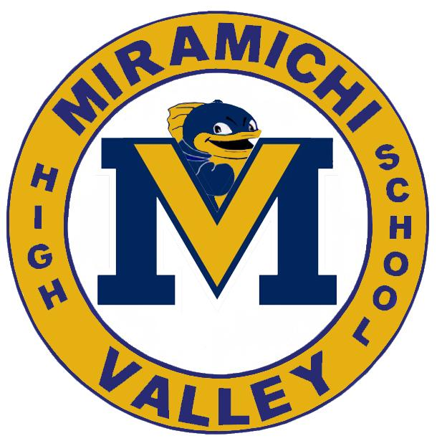
Miramichi Valley High School
2021 Grad Activities

Dear 2021 Graduates of MVHS,
We know this year has been disappointing on many levels and has been a graduation year unlike any other. Our graduates have expressed disappointment about not being able to gather as a group for classes, meetings and other celebrations. To help graduates feel some sense of normalcy and gather as the MVHS Grad Class of 2021, we are planning to hold two Physically Distanced Grad Activities.
The first will be a Winter Activity Day on March 16th and the second will be a MVHS Safe Grad Lunch and Activities held the last week of May. Planning is under way for the March 16th event and we are confirming what activities we will be able to offer safely for the Grads. Stay tuned for a signup sheet, which will be coming to you as soon as we have the events finalized. Unfortunately, events will need to have limited capacity in order to follow all Covid-related protocols. Lunch will also be provided to students on March 16th.

