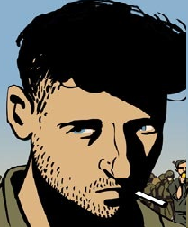
“The Sniper” – Open Mind Portrait
- When I stop part way through the story, use the first blank portrait to draw
what you feel the sniper is thinking. It can include feelings he might have,
pictures in his mind, fears, memories.
- At the end of the story, use the second blank portrait to draw what you
feel the sniper is thinking.
