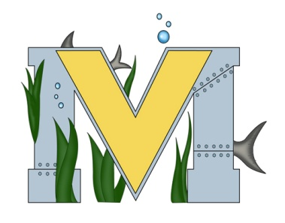
Pre-Dive Checklist

Materials To Bring…
Laptop Map of Dive Site Tie Wraps Paper/Pencils
Batteries GoPro(s) Duct Tape Flashlight
Memory Card(s) Sony Camera Electrical Tape Multi-Tool

Inspection…
- Check that memory cards are present, have proper capacity, and have available space.
- Check that propellers aren't damaged.
- Check that components are secure and no damage is present.
- Insert batteries and battery adapters (if using LI-FePO4).
- Using a digital multimeter, measure the voltage across each battery tube at the DB-25 connector. You should have around 12 volts.
- Close E-tube and pull o-rings back up from under electronics tube and attach them to the hooks above it to hold it in place.
- Check that o-rings are seated properly in E-Tube and battery tube
- Unspool tether and put on a holder and check for nicks and scrapes. Do not use if tether compromised.
- Spray DC brushless motors with silicone (Recommended)
- Weight ROV on front threaded rod with fishing weights
- Check that plungers are in the E-Tube
- Test connection to ROV with a PC. If connection fails, verify all PCBs are pushed together tightly
- Check lights…low / medium / high / on / off
- Check video signal
- Check lasers…turn off / on
- Check camera… pan / tilt / zoom (as appropriate)
- Check Heads Up dashboard if you have an IMU
- Use keyboard and cockpit to test motors
- Put your ROV in the water
- Verify Neutral Buoyancy
- Drive ROV… forward / backward ; turn to port (left) / starboard (right); ascend / descend
- Turn camera servo up and down, verifying PC video stream
- Dive to 1m and hold depth
- Leak check after 1 minute in the water

Signature: _________________________ Date: _____________ Time: ________

