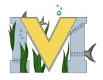
FINAL PROJECT PROPOSAL
Names: Nicko Stewart
Project:ROV
Part A: Project Ideas & Objectives. To finis the ROV to have it fully functional
Part B: Electronic Resources. MATE
Part C: Materials, Design . SOME 3D PRINTING , solder, solder iron, VOLT METER, some pipe and pipe glue

