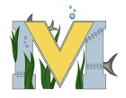
FINAL PROJECT PROPOSAL
Names: Justin murphy and spencer colepaugh
Project: trebuchet
Part A: Project Ideas & Objectives- for are second project we are still use the trebuchet and finish it are second tech is going to be drones with go pro’s and possibly do a vinyl rap we like to use the drone technology to enhance are video footage of are project and get many different angles and views. biggest goal is to finish trebuchet.

Part B: Electronic Resources
Part C: Materials, Design

