Journal 3
This week we ran into some hiccups with our 2nd idea for this project the bottom left edge of the card sleeve kept on curling up we also ran into problems with the new filaments (the black PLA 1.75mm; mainly) after an entire class of Mr.Hallihan and I attempting to fix this problem our last day he gave us a mini-assignment to find some ways to fix the problem. This week not much was done due to Zach and I possibly needing to rethink our project for the 3RD time.
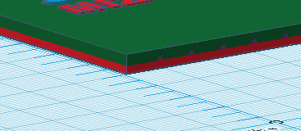 This was the edge that curled up on all of our prints

For the trouble shooting
https://filaments.ca/pages/temperature-guide

