This week in the makerspace we did quite a few things, Justin and I with the help of Mr. Hallihan designed some names in Silhouette Once we were finished finding our desired font, and character size we printed them on to some heat vinyl, we then went to the heat press and placed the names on to some shirts. In doing that we got a good feel on how to operate the heat press so we tested placing a logo on to a sleeve of a shirt. The logo looked pretty good and I was happy for it. My next goal is to learn how to print more detailed images on to clothing, such as these lightning bolts I designed:
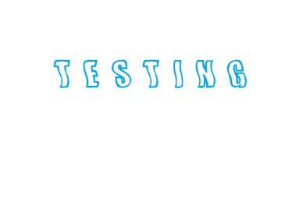
Logo I printed on the sleeve of the test shirt

I think I’ll have to go to a printing store and discuss prices with them, and see if they’ll be nice and cut me a deal if I choose them as a main printer place for my clothes. If not I’ll save money and maybe buy my own vinyl heat press, and a vinyl cutter, but before I even think about doing any of that I have to wait and see if my things will even sell if I begin printing.
I’ll print 10 out to start and see if they sell. My uncle owns the pawn shop, and his friend owns day dreamers, so I was thinking about asking them to sell my clothes in their stores if I cut them in by a % of what I make in the end.

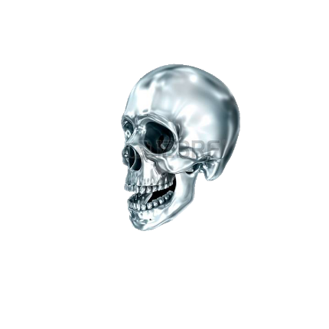
I also have to purchase a drawing pad for my computer so I can make a skull logo. Need being that I need a skull I designed myself to avoid copyright infringement. I can’t find anyone who would be able to draw it out for me, but I need something like this (except facing forward):

I also need to learn how to create fire in Photoshop, I already learned how to create lightning. The goal for this sweater is to look like a 80’s band sweater. I got some inspiration from old Metallica, and Iron Maiden band merchandise. I could never find one around, so I figured hell, I’ll make my own. Also I need to buy some plain clothing for printing things on, I thought I had seen some laying around at my Grandmas but I was mistaken, so I couldn’t print today like I had planned.

