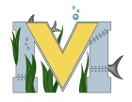
FINAL PROJECT PROPOSAL
Names: Nicko Stewart
Project: Steam whistle and Hydrogen generator for gas powered engines
Part A: Project Ideas & Objectives
for the steam whistle i would like to build a working model using the 3D printer
for the hydrogen generator i would like to buil one for my truck.
Part B: Electronic Resources
https://www.youtube.com/watch?v=RqbV1pQ6zpo

https://www.youtube.com/watch?v=JRuYjDs2rFw
https://www.youtube.com/watch?v=dt8wtOkUukQ
https://www.youtube.com/watch?v=bED2Z_wdISg
https://www.youtube.com/watch?v=_O3-C-19qHE
https://www.youtube.com/watch?v=u5nld6HzEjM
Part C: Materials, Design
for the steam w whistle it just needs to be 3D printed
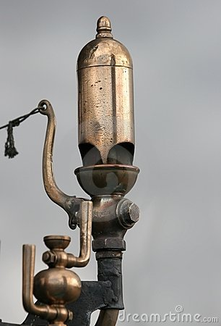
for the hydrogen generator i need a clear jar with lid and clear flexible hose and a roll of aluminum wire 2 bolts 4 nuts 2 washers a tube of goop and to 3D print a holder for the wires
