Justin and I have begun creating a clothing brand, Justin is in charge of business plans, and I’m the creative force behind the project.
To begin, we Downloaded some software’s that we needed to use such as, Adobe Photoshop, and paint. I taught myself how to use this software.

Adobe Photoshop (CS6):
Is a software used by professional artists, and multi-million dollar companies I think it is one of the best photoshop software’s personally. It is easy to navigate and use.
Paint:
Is a free Windows application that you can use to quickly edit photos I don’t use this application often, but it’s always there for when I need to.
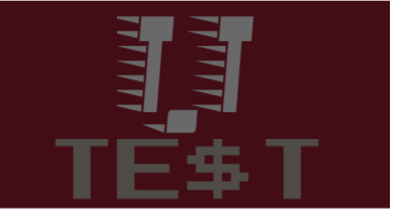
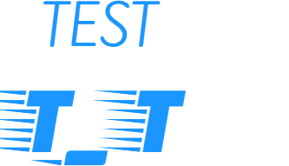
I then began designing different logos for our brand. (Not finalized)
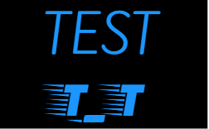

I am still on the ropes for finalizing our logo, and brand name. I am having trouble thinking of names because we live in such a small town, I don’t think many people would be interested in a fashion or streetwear brand, so I was thinking about just making a fitness brand instead, even though I’d much rather create a fashionable brand. I’ll start off with simple logos to introduce people to the brand, and over time create more complex logos with deeper meaning. For now I’ll just stick with a symbol, or small logo.

Mr. Hallihan taught us how to make stickers with vinyl last week. I made some stickers that I placed on my lap top, and some things at home. These stickers will help the brand because I was hoping to include a free sticker with each purchase. This way it will give us some novelty.

I also started designing a website which I will link here website design is nowhere close to how hard you think it would be. We have websites now that assist you in making your website, making it an effortless job that yields great rewards. All I’m waiting on now is for us to create some merchandise, so I can begin advertising online.
Our next step is to create our first piece of clothing and bring it to market. Justin has deals set up with one of our partners to sell some of our clothes at the gym.

