Journal #2
We first found this program on the internet that allowed us to program the remote. We then uploaded the code to Arduino and then it worked with the remote control that comes with the Mbot. However we ran into some problems with the coding, Right wouldn’t work, left turned right and forward and backwards worked though. We looked up different types of code that we used to then try and make the robot work better, but the uploading kept failing. We couldn’t keep the robot connected to the Makeblock app that we are using, we would try and upload the code, it would then say upload failed and the robot would disconnect. We are still researching how and why it would be doing this. As well I tried connecting the robot to my phone via Bluetooth, but that stopped working as well so it could be something in that actual robotics of the Mbot that is messing things up.

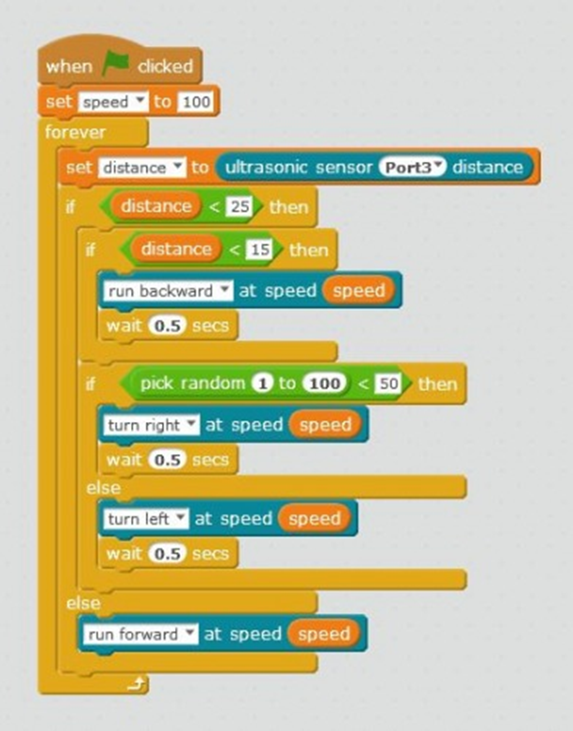
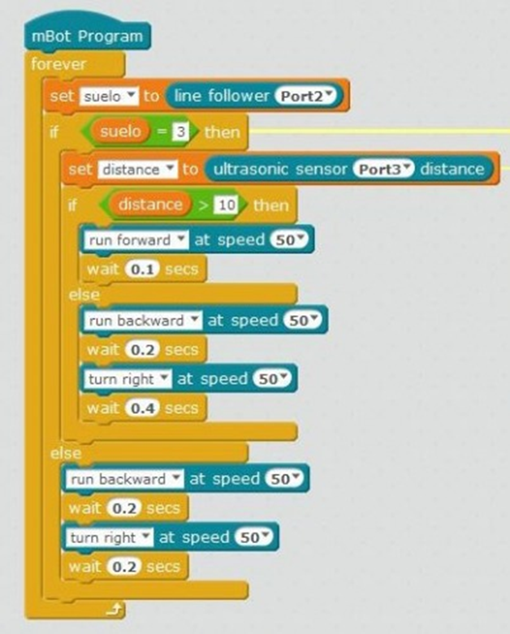

http://www.makeblock.com/me-joystick http://www.instructables.com/id/mBot-controlled-by-Wireless-Joystick-using-Me-USB-/
https://www.youtube.com/watch?v=ZxVw-auuYho
http://forum.makeblock.cc/t/programming-the-ultrasonic-sensor/3315/5
http://www.makeblock.com/mcore-main-control-board-for-mbot

