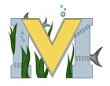
PROJECT #2 PROPOSAL
Name(s): Zac(k) Squared
Technology:
Part A: Project Ideas & Objectives: Our idea is to program the mbot and learn how to code the mbot to control it in different ways. Whether it’s through different commands using our phone or the remote that comes with the mbot kit, we just want to learn how to program it to do exactly what we want. We also want to attach a camera and possibly a microphone to it so we can see and hear exactly what’s going on where the robot is, without having to be close to it. We could then control it from a distance and see exactly where we are going.
Part B: Electronic Resources:
http://www.makeblock.com/mbot-v1-1-stem-educational-robot-kit
https://scratch.mit.edu/

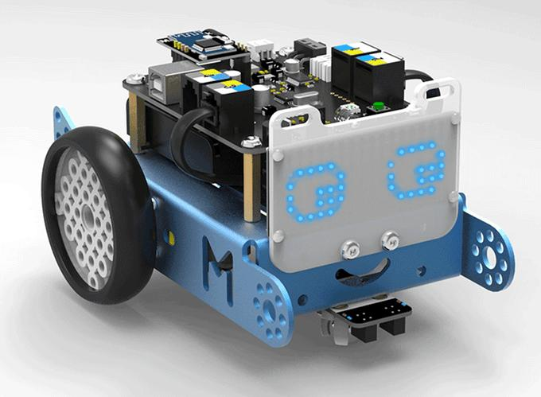
Part C: Materials, Design:
Mbot, GoPro, Computer

