Summary 1
This week started off with the controller case but we switched over to making a card holder for the back of phone cases; we made four different designs but the first one I forgot to raise the 2nd part so it did not print the hole. Two of them (Zach’s) ended up curling when being printed. Right now we are waiting for the fourth design to be printed so we can move on from here.

Site used for the designs: https://www.tinkercad.com/
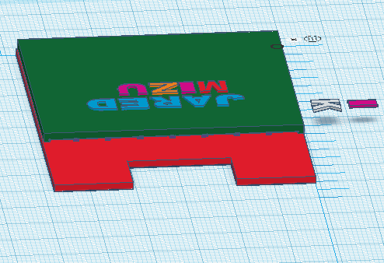
picture of design used for 1 and 4

