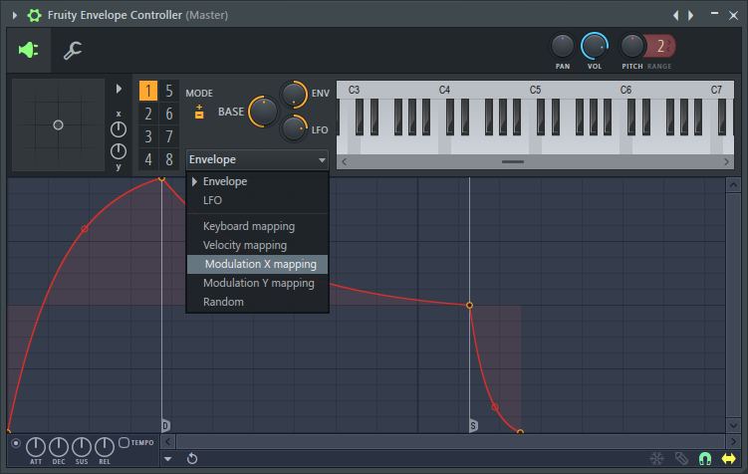 |  | Oakley, Zach G  - Journal #4

rECORDING VOCALS

This week in the maker space Zach and I began to teach ourselves how to use the pocket synthesizers, supplied from the makerspace. We have created a number of symphonies, and are now debating on which one we should re-create inside of the F/L studio program which I taught myself to use, along with the help of various YouTube videos. We also learned how to Auto-Tune voices inside F/L studio.

We are also trying to decide what genre of music we are going to pursue in the video, we could do techno but I’d like to do a funny song, starring Zach Galley.

All my recording supplies so far have come from home, I’ve been bringing my laptop, keyboard, and a microphone to class, but I will need a camera soon, to record the music video. Most likely will use a camera from the makerspace.

We couldn’t find a good sounding beat with the pocket operators it didn’t match the other beats off the other operators and we haven’t been able to find a nice beat yet.

Report
By Oakley Genova

