Journal #3

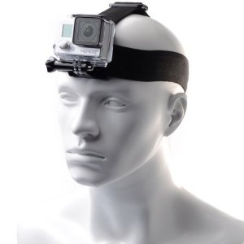
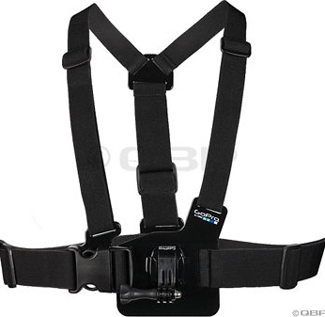
This week in the MakerSpace we took our technology down to the Mez with another group who was doing the same. They were flying two different drones and we were recording footage of that with the Go Pro. We took some footage of that with the Go Pro free hand and then took some of Zack and I having a catch with the football to see what it would look like. We had the Go Pro mounted on my chest to get a more realistic perspective. The only real thing we didn’t do yet was put our footage onto a computer and mess around with the editing process. We have only taken raw footage so far up to this point. The only real problem we had was learning how to attach the Go Pro to the head and chest mount and having to tighten the chest mount to my chest to make it fit properly and so the footage wouldn’t be very shaky.

