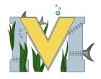
PROJECT #1 PROPOSAL
Name(s): Zack Boudreau, Zac miersch
Technology:
Part A: Project Ideas & Objectives
For a project idea we are going to look at different Perspective a catcher, pitcher, and batter during the events of a baseball game. With this we will turn the perspective into virtual reality to. We are possibly looking at continuing the blue tooth baseball project that Zach and Ben started last year.
Part B: Electronic Resources
https://www.youtube.com/watch?v=REoWro4DVVQ
https://www.youtube.com/watch?v=BPZo-ep184U
https://p6.zdassets.com/hc/theme_assets/922943/200212897/FLY008-14_4K_User_Downloadable_PDF_ANDROID_A4_v6.pdf
https://www.youtube.com/watch?v=sEBe6hVXXHA
https://www.youtube.com/watch?v=To2m40Pb4H4
https://www.youtube.com/watch?v=uulGm3tRC10
Part C: Materials, Design
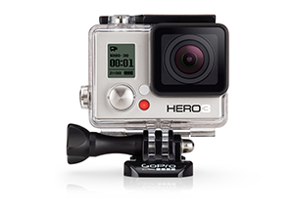
Go Pro

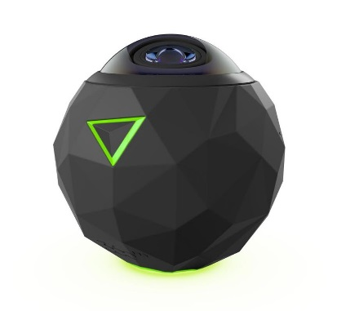
360 fly

Ball gear (gloves, catchers gear, bats etc.)
