The Pulse Motor is basically done, but we need to test it still. In my video, I have explained what each component does in the video.

A Pulse Motor is a highly efficient motor that uses small amounts of electricity to move the motor. Some energy being used can also be recovered, but it slows the motor down. (if we had neodymium, it probably wouldn't slow down very much, because we would have better torque) Our Pulse Motor isn't professionally built, and shakes a lot too. The coil we used isn’t the greatest, the wires are too big, especially the trigger wire (the trigger wire There’s a lot we must improve, but first we want to see if our jury-rigged pulse motor properly works even though we have not built it by the book.
I may have said that it recharges a battery, but I have yet to prove that. I may require neodymium magnets, that could be the problem too.
Also, found out that it can be used to make batteries desulphated.
Cheap and Good battery that I’m thinking of buying.

https://www.amazon.com/ExpertPower-EXP1250-Alarm-Battery-Terminals/dp/B00AAZJF4C/ref=sr_1_2_s_it

NOTE: This Journal was to be uploaded Friday, but I forgot to do so.
Transistor, Neon Light, 1N4001 Diode, Copper Coil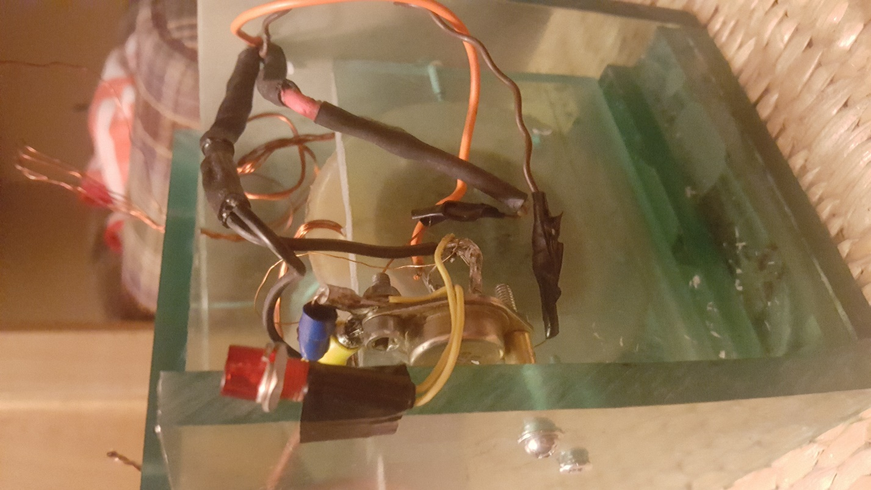
Entire Pulse Motor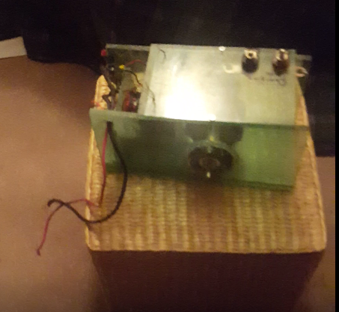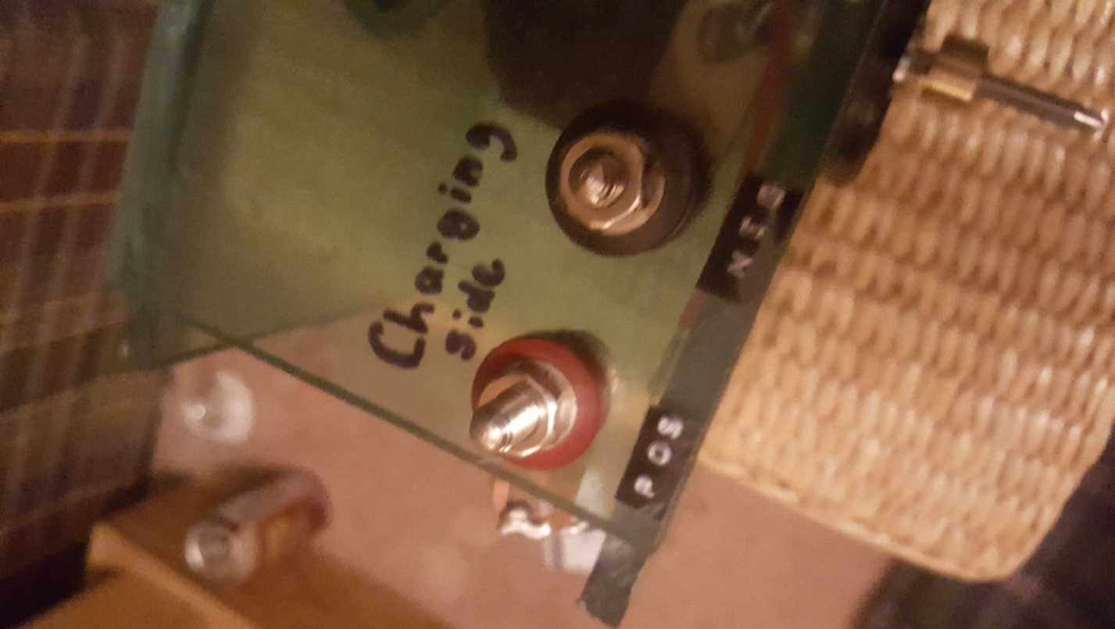
For the recovery battery (output battery)
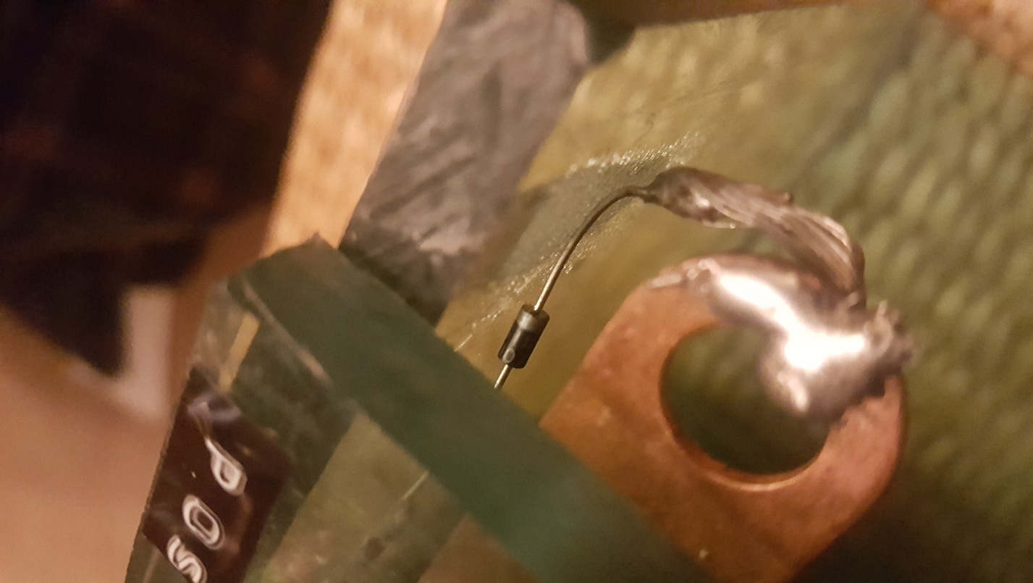1N4007, to send the current one way. (which is to the recovery battery or ‘output battery’)

Not part of this project but I found something cool to do in class, although you may have already seen and used.
https://www.youtube.com/watch?v=_cKb3oEM47E

