Journal #1
James MacGregor
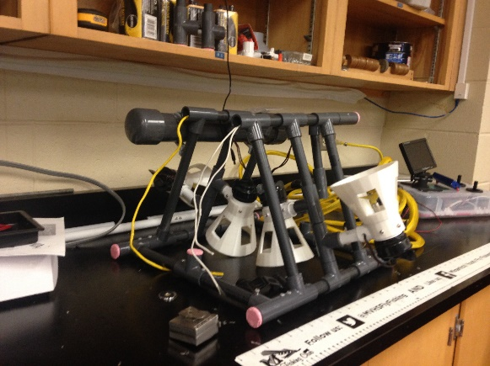
The underwater robot had light sockets already half installed into it but I didn’t need them because the camera that I am going to use already had LED’s around the camera so I pulled out the wires for the lights. It made more sense to get rid of them because the robot won’t be going very deep anyways. In order to put the acrylic tube on the front of the robot I have to 3d print a custom pipe so that water wont leak on the camera. On the M.A.T.E website I found a document which had the wiring diagram for the camera onto it. I found all of the included parts that was sent for the camera and put it all together. I flicked the power on and It worked perfect. I think that that was the easy part because now I have to get longer wires and wire them through the underwater robot to get to the front so we can see where it is going from the surface. I could have got more stuff done but we had to get our high-altitude balloon (from my last project) ready because we had a potential launch date planned for the following week.

