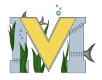
PROJECT #1 PROPOSAL
Name(s): Darius Comeau, David Wilson
Technology: Sphero robot, iPad
Part A: Project Ideas & Objectives
To create a 3D obstacle course for the Sphero to teach people how to control the robot.
Part B: Electronic Resources
Sphero Robot, ipad or Personal Device
Part C: Materials, Design
Potential designs are below, while the materials needed are most likely going to be building blocks of some sort.
