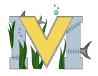
PROJECT #1 PROPOSAL
Name(s): Matthew, Justin and Ryan
Technology: mBots
Part A: Project Ideas & Objectives
http://www.brilliantlabs.ca/mbot-intro
https://www.youtube.com/watch?v=lKvBRIc13MY
https://www.youtube.com/watch?v=QKpwW9EXo9I
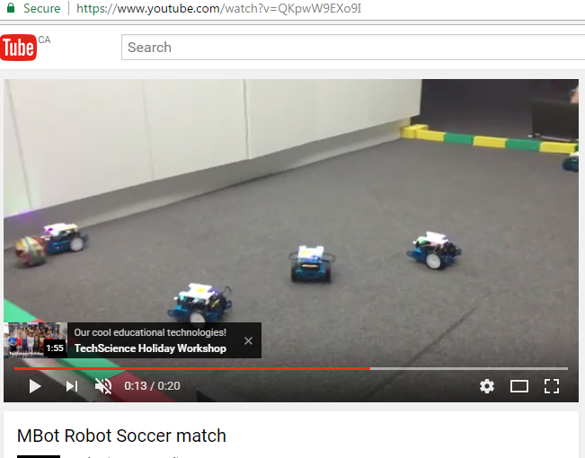
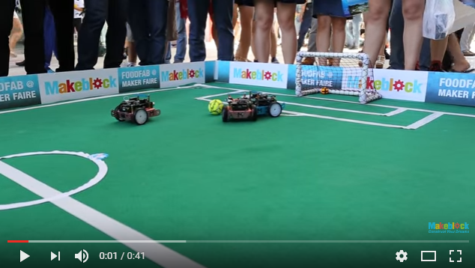
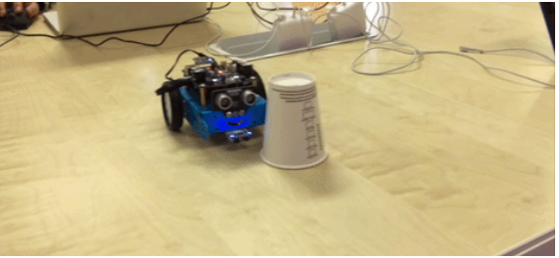

Want to make soccer game with mBots
Part B: Electronic Resources
mBots: 3 Laptops, Phones
Part C: Materials, Design
2-3 Blue tooth mBots (17 x 13 cm), Soccer ball, nets (string, Cardboard and size 45 x 15) Field (274 x 150 Table)

