PROJECT #1 PROPOSAL
Name(s): Kevin Martin-Savoie
Technology: Pulse motor
Part A: Project Ideas & Objectives
This idea came from my dad, who worked on one for 6 months during his free time. It requires electricity to make more electricity. It barely uses a battery and it efficiently – very efficiently uses power to make power. If you have any questions ask me, although I may not be able to answer some as I am still exploring this technology.
I wish to create one, it may not be new technology but it’s cool and I haven’t really seen it used much.
Part B: Electronic Resources
https://www.youtube.com/watch?v=ttY7yLXZSpo&t=47s
https://www.youtube.com/watch?v=RGiQqu2D-BI
http://www.instructables.com/id/Simple-Pulse-Motor/?ALLSTEPS
http://johnbedini.net/john34/bedinibearden.html
Part C: Materials, Design
Copper coil(s)
Something to hold it together (like wood blocks and electrical tape)
scrap electronic components (from microwaves, Guitar amps, etc (Just old stuff))
5v Battery to 12v
A couple of magnets (about 4)
Welding rod (or non-magnetizing rod)
Good bearing rod (can come from vcr) (for spinning the magnets)
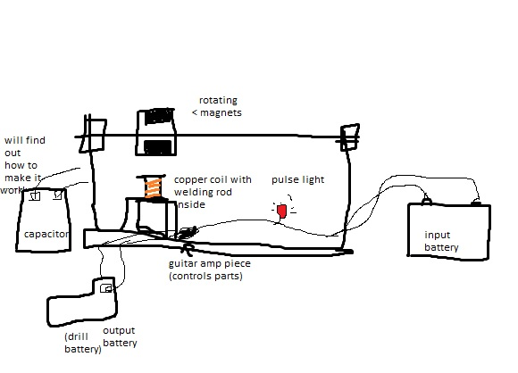
Pulse light (for checking how many pulses or using excess electricity)

More copper coils could be added to create more electricity
Other stuff I thought of making
Solar phone charger (with battery if no sun)
door you can lock/unlock with your phone
survival kit or something (minimal amount of calorie intake/some kind of hydration counter.)

