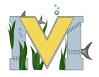
PROJECT #1 PROPOSAL
Name(s): Joshua Benoit & Emily McCabe
Technology:
Part A: Project Ideas & Objectives
We have chosen to partake in the opportunity to work with the vinyl cutter. In order to gain experience with the vinyl cutter, we will take leadership within the school sign project. To expand our experience with the vinyl cutter, we would like to attempt stencil making. We will use our stencils to paint an image on a wooden surface.
Part B: Electronic Resources
https://www.silhouetteamerica.com/handmade
https://www.youtube.com/watch?v=-9uQwfyv0RU
https://www.youtube.com/watch?v=EAckTnc4XD8
http://www.thepinningmama.com/how-to-make-any-font-a-stencil-with-your-silhouette-cameo/
http://www.silhouetteschoolblog.com/2016/07/silhouette-cameo-3-release-getting-started.html

Part C: Materials, Design
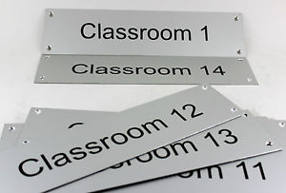

- Replace writing on signs with teachers names.
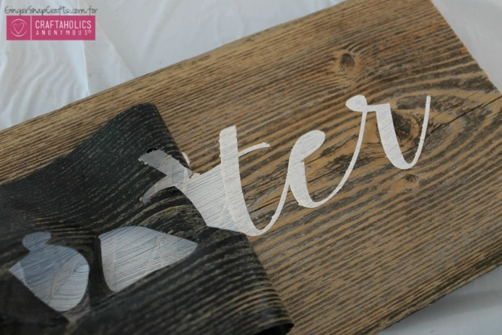
- Customize signs to match school colors.
- Use cardboard like material for signs.

- Create stencils.
- Paint image/writing with custom image/writing design.
- Create multiple designs such as writing (quotes), and images.

Silhouette Vinyl Cutter (Cameo, and Cameo 3)
Vinyl material
Wooden Surface
Paint

