Final Journal
My highlight moment of the semester would by designing with the 3d print despite my designs not being the best, it was still fun. My favorite event was going to the East Coast Life Styles speech I really highlighted what we -as some kids with ideas- can amount to. I had a couple of frustrating moments in this course; the main one was having no computers with tinkercad working on them for about 1 week for the 1st project. The 2nd projects main frustration was the 3d printer not allowing my partner or I to really get our 2nd project off the ground due to it not being able to print our designs.
Creativity: I feel I increased my creativity slightly but I still really am not that creativity. As you were probably able to tell from me asking you for ideas for the 2nd project
CRITICAL THINKING & PROBLEM SOLVING: this skill has increased a lot for me due to the fact I would normally give up after the first try.
COLLABORATION: I learned that people will –for lack of a better term- Jew you into doing most of the work but in the 2nd project I found that it was slightly less all on me
COMMUNICATION: I learned communication is key for projects like this especially if one of the partners are not always here so at least some work could be done.
A key thing that I took away from this course is patience and of course the 3d designing skills I’ve started to develop
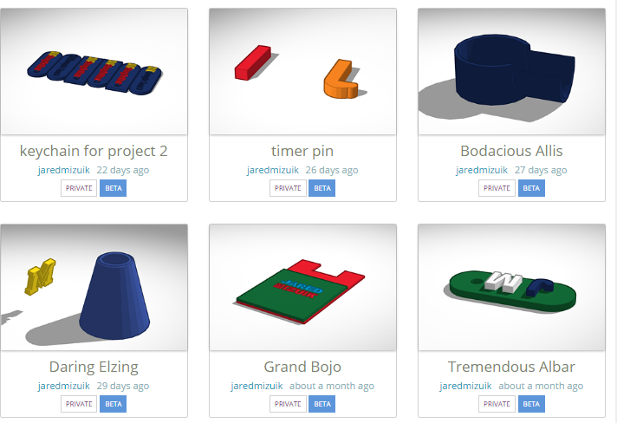

These were all the items I designed during the term

One critic I have is your speeches now they are inspiring and helps each group will there project but they take up 15 or so minutes each class that everybody could have been working and you could of just went to the groups individually instead of addressing each group to the whole class.

