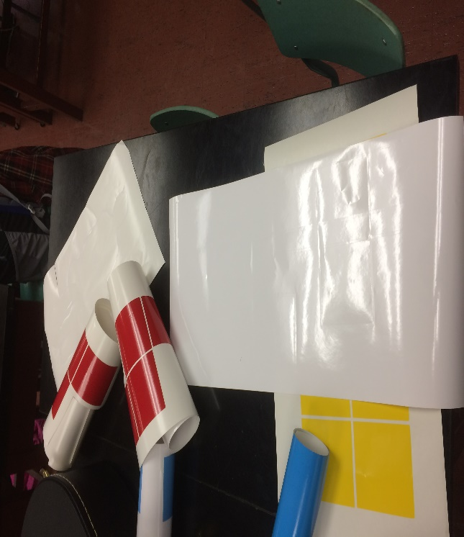
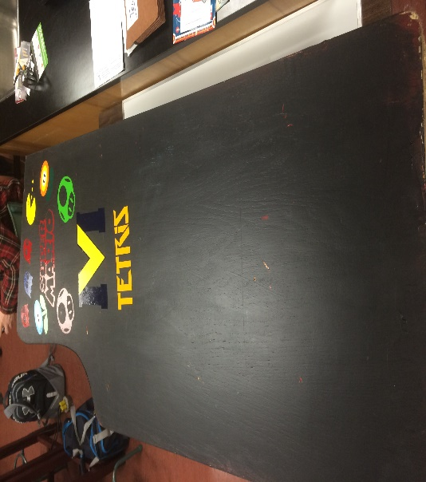
Final Journal Entry
Highlight Moment
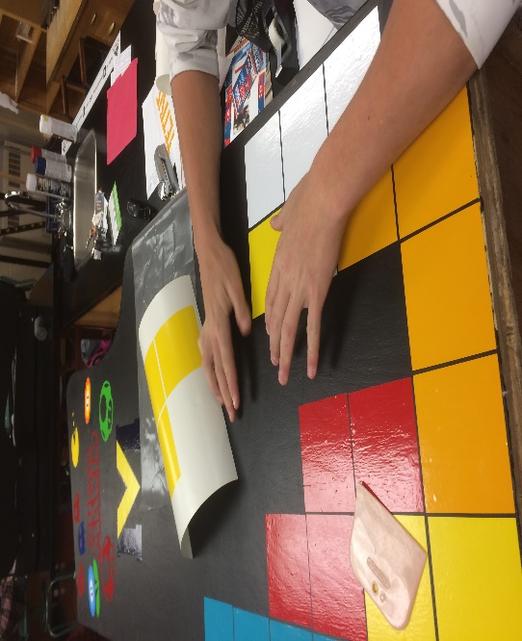
-This course had a lot of fun moments in it and I enjoyed spending time with the people in the class and in the environment. However, the highlight moment for me in this class was when we went to NBCC to watch Alex MacLean speak about how he developed his East Coast Lifestyle company. I found it very interesting because he was an average everyday student who one day came up with this great idea that just took off. It was easy to relate to the guy and that made the experience even more interesting and motivational. I found the topic related well with the class because our class is all about finding new and different ways to develop things and possibly sell it to the public.
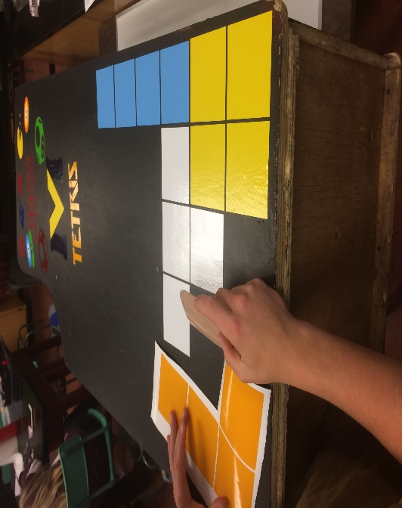
Most Frustrating
-Although there were a lot of frustrating moments in this class I found the most frustrating was having to deal with the silhouette machine. Sobey and I worked on the Arcade Machine a lot throughout the course so we had to use the silhouette machine a lot. It jammed all the time and the cuts slipped a lot or we would print it too small or it would rip when we pealed it off. It was a headache. Ben and I probably did not have the best working system going though. Once we got a hang of it, things went pretty smoothly.
4 C’s
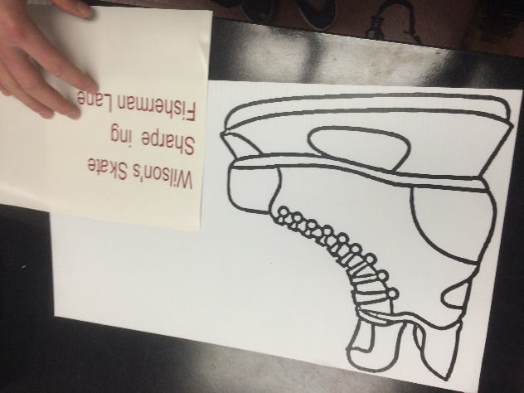
CREATIVIY- This class was all about creativity we were pretty much allowed to think or do anything within reason. I found that I really had to apply my creativity when it came to the Arcade Machine. We had to think outside the box a lot when it came to putting the Tetris pattern down. A lot of times we just played it by ear but it all worked out in the end.
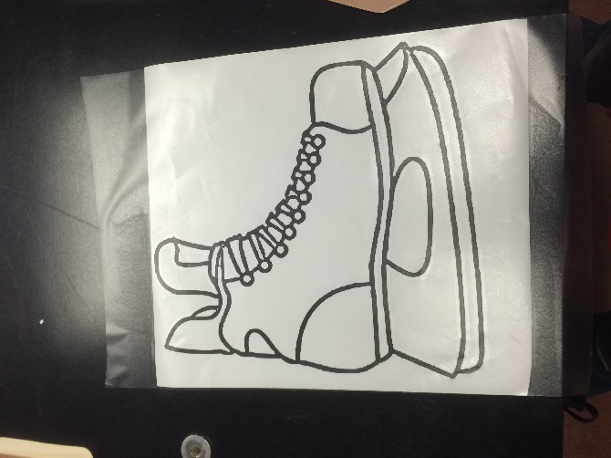
CRITICAL THINKING & PROBLEM SOLVING- Sobey and I ran into a lot of dead ends in this course We had a lot of problems with the silhouette machine. But we figured out that it is easier to just draw a game plan before actually approaching the task. That way things would go a lot smoother and we would not run into as many problems.
COLLABORATION-There was a lot of room and time for collaboration in the class. We collaborated a lot with the skate sign thinking of new ideas in how to represent it to the public.
Key take away
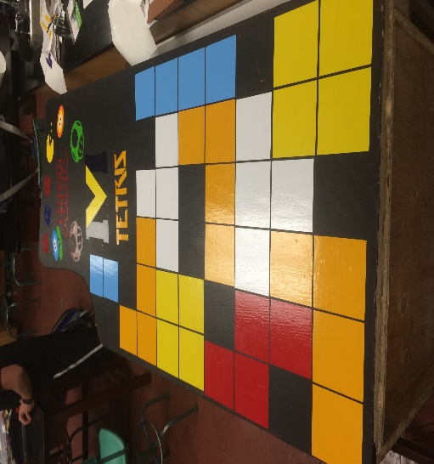
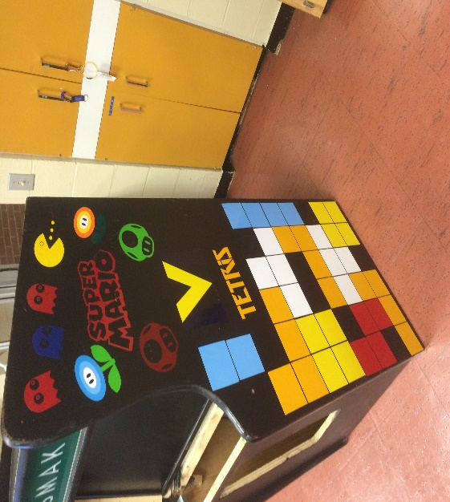
-The biggest and most important thing I’ve learned in this course I think will benefit me a lot throughout my life will be how to work with others. In this class, we worked mostly in groups so it is vital to be good with others and I believe I learned to be more skilled with being able to cooperate and learn to compromise better. Not only were we a class room but we were a community of individuals striving to reach the same goal in different ways and ideas. Definitely an important life skill I will incorporate into my daily life.
Contribution
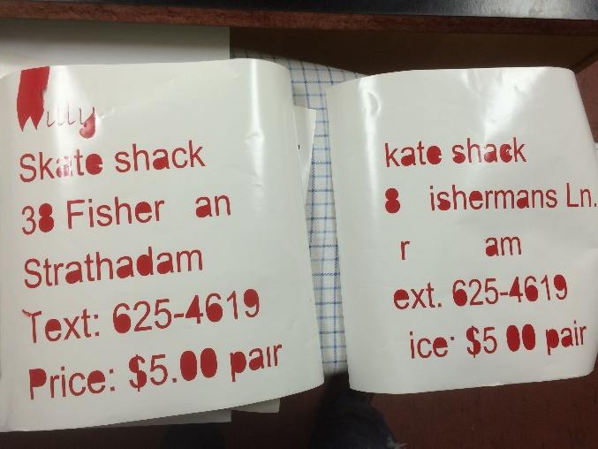
-My biggest contribution to this class would most likely be the Arcade Machine Ben Sobey and I worked on it for a while. We printed and made the Tetris pattern and we made an instruction video on how you can vinyl print yourself as well. We customized the pattern and put wheels on the bottom of the machine so it is easier for it to maneuver around. Probably my proudest accomplishment in the class.

