Journal 4
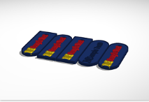
This week we had to yet again give up our project idea and start anew this time around we went with a project we knew would work with the 3d printer a simple keychain design- the same model we used for the keychain assignment –but with a twist we designed multiple modes that alternated a round side and a edged side; as well as models with both sides round or edged. But still we printed some models but the “raft” altered the models not giving them a clean look or feel.

