Journal #5
- My highlight of the course was probably using the GoPro to capture the perspective of me pitching from the catcher’s perspective. It was cool to see it from the catcher’s side instead of the pitchers. I always wanted to see what my windup looked like so this gave me a chance to do that.
- The most frustrating part of this course was without a doubt working with the Mbot and trying to get the Bluetooth to work. We had a lot of problems with the Mbot but this is pretty much one of the only problems that we haven’t found a solution for. We tried reading multiple articles and researching on multiple sites but we still were not able to come up with a solution.
- Four C’s:
- Creativity: I think for creativity I gained a fair bit. I have new ways that I can use my imagination, for example using the GoPro it allowed me to be creative with the angles and even the ideas that we could do.
- Critical thinking and Problem solving: This course taught me a lot in this particular topic. I discovered new ways to research specific things online, I also learned that when it comes time to problem solving often times you are thinking too hard and the solution is literally right in front of you but you just do not realize it. One problem that we had with the Blue tooth was we didn’t have the right chip connected to the Mbot but we didn’t even know that because we were thinking way to hard
- Collaboration: Working with Zac was very easy. We have been friends for a long time and we already have a lot of experience working with each other. We play baseball together so teamwork is constantly needed. I would say that we just gained more experience working with each other more than anything.
- Communication: Communication would be similar to collaboration, we already have plenty experience working as a team so communication is always good between us. We never fight and we always know how to come to an agreement between each other. We usually have similar ideas anyways so it usually works out really good.
4)The Key take aways for me would probably just be the skills that I improved on, so the four C’s. This course really helped me not be stressed out constantly to, instead of having a set class plan to follow and test that we are forced to take, we basically get to make our own plans and it allows us to open up our creativity and imagination a little more.
5. 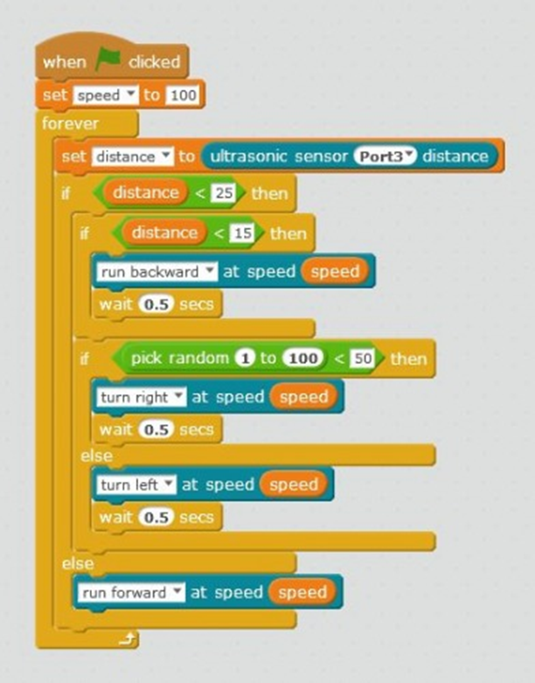 This was one code that aloud us to solve one of our problems with Mbot. This code uploaded to arduino with no problems what so ever.

