http://mvhs.nbed.nb.ca/mvhs-make/note/final-journal-entry
1. Highlight Moment:
My favorite moment of the entire class was when I first got to use the 3D printer. It was a new technology that I was very interested at the time. There were plenty of failed prototypes, but there usually is when you are new to any type of thing.

2. Most Frustrating Part of the Course:
The most frustrating part of the semester was the 3D printer failing on almost every single print made me very frustrating because we couldn’t find out why it wouldn’t work, but in tinker cad, it was perfect.

3. Discuss the 4 C’s: CREATIVITY, CRITICAL THINKING & PROBLEM SOLVING, COLLABORATION, and COMMUNICATION
Creativity is a key part of a class like MAKE. You need to have new ideas that are always aiming towards a future goal, and that nobody else has thought of yet. Critical thinking and problem solving is important to proceed further with your ideas. Collaboration is important in the aspect of using all technologies to their combined potential. Communication is important in both verbal and coded languages with the different technologies and the people working on the project because it gets everyone on the same page.

4. Key Take a Ways:
My key take a ways from this course are all the new skills and knowledge I have picked up on throughout the semester. I have learned how to use a 3D printer, how to use a vinyl cutter, how to use a heat press, I learned a bit of coding and soldering, and I learned better ways to problem solve and sparked some new creative ideas.

5. Here was the Beatles Guitar before it was finished, I repainted the whole guitar, but I don’t have a picture of it. We also 3D printed a pickguard with John Lennon’s signature on it. 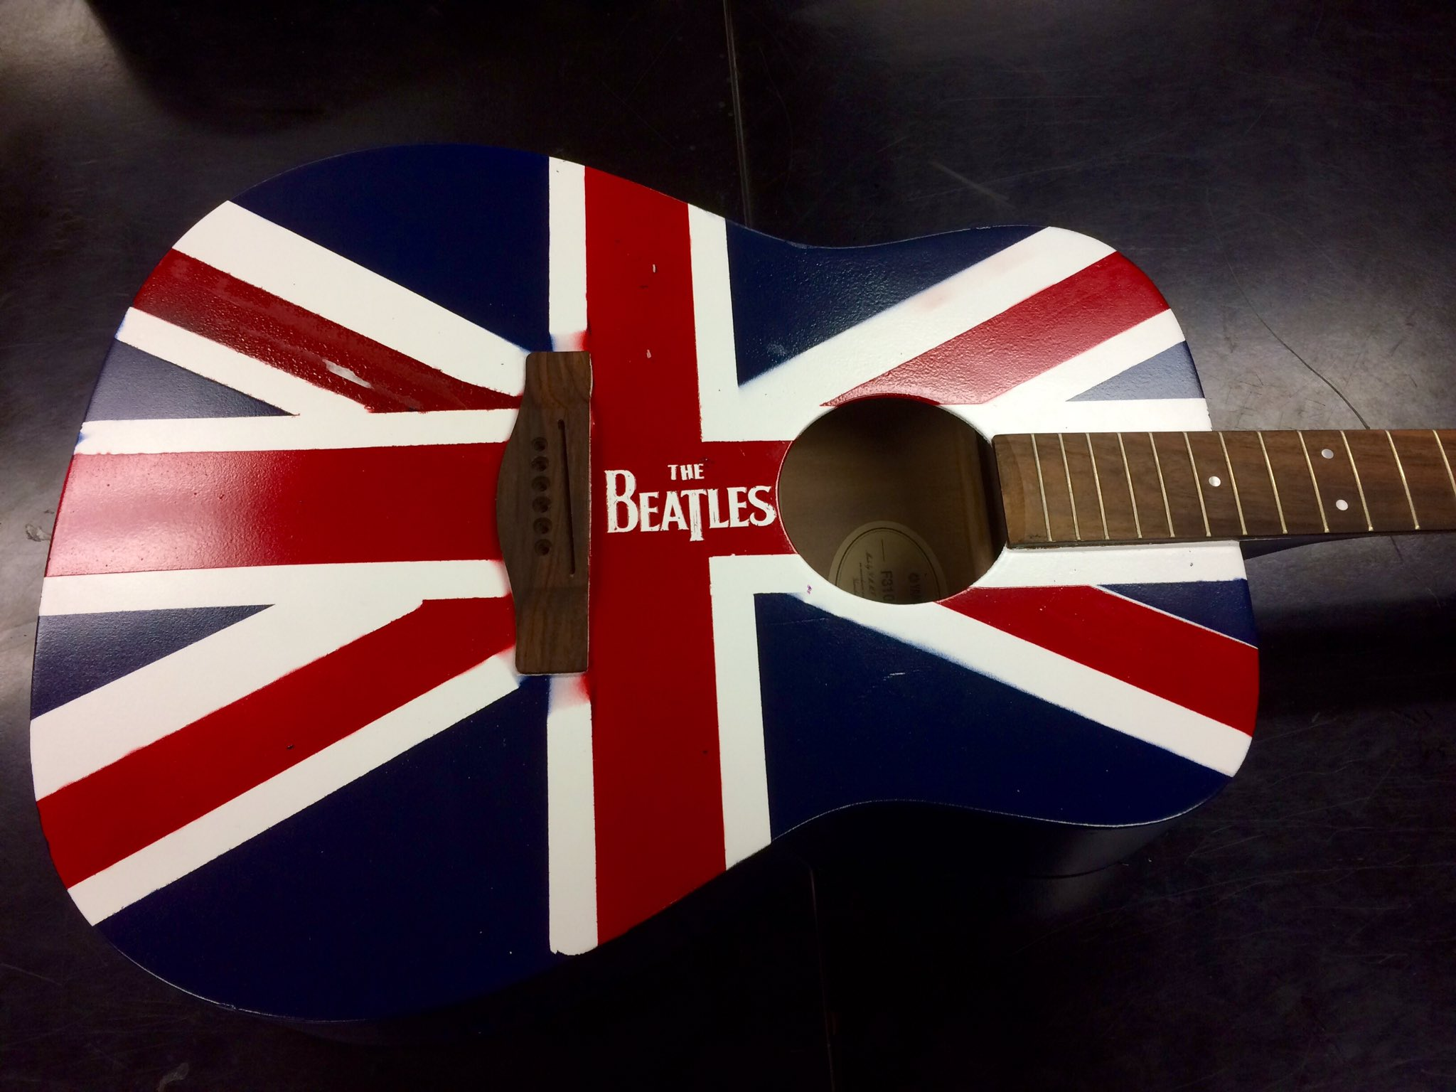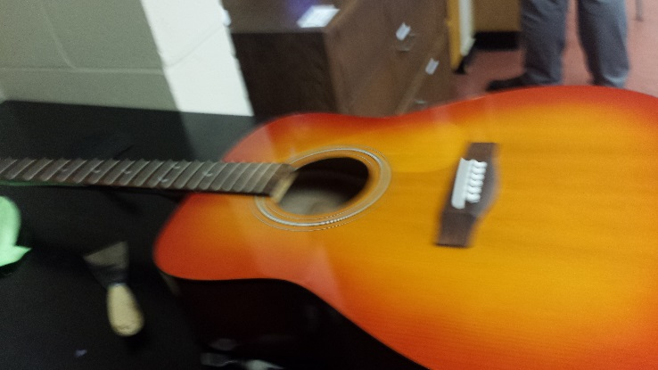 The original Guitar
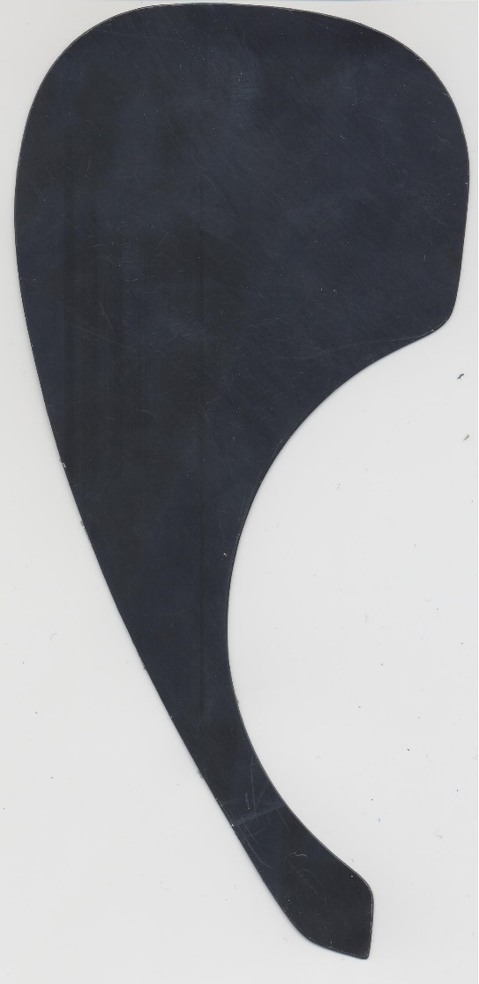 The scan of the Pickguard
