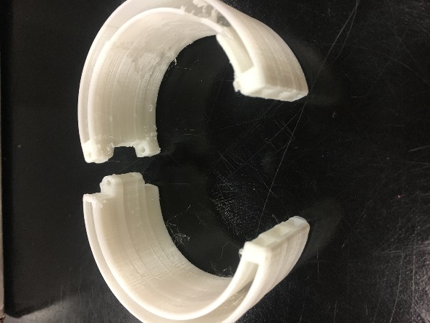
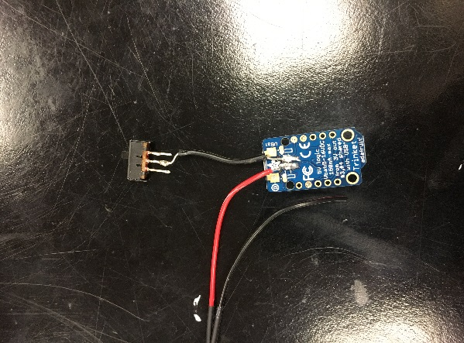
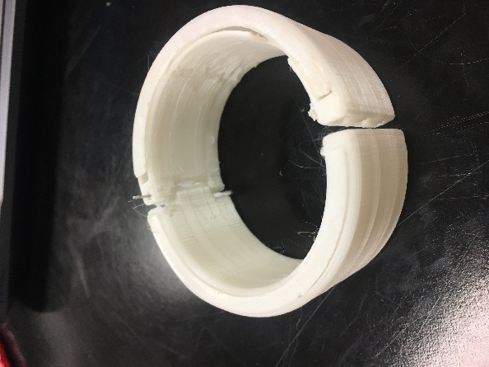
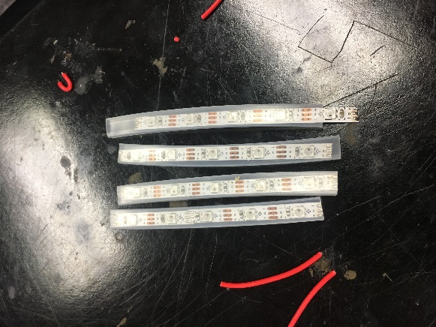
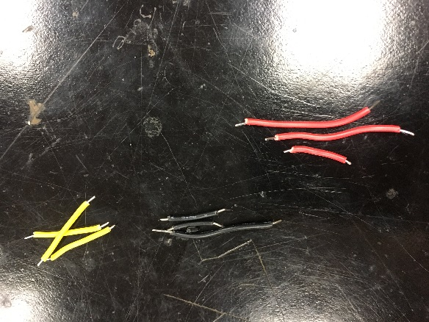
During the past few weeks of our final project we began searching new ideas we could do for our project. We finally came up with the idea to make Neo Pixel Bracelets for ourselves to use. We first searched how to construct the bracelet and ordered all the material we needed for it. The material we used was neo pixel strips, magnets, pins, and glow in the dark filament to construct our bracelet. At first we had a hard time figuring out the steps to make the bracelet but we found a very useful website on Adafruit that told us step by step process to assemble the project. There were also a video that we looked at to build it. During the course of this project we had difficulty soldering the wires to the trinket board because of it being so much smaller than the floraboard connection we used before. Everything had to be so persist so it could all go into the bracelet and light up. We haven’t fully assembled the connection and bracelet yet but we plan on doing that over the course of this week. Our group thought this would be a more fun way to use neo pixels and soldering to use it for something we like and would use in our life. We learnt more better ways to improve our soldering skills and even learned how to use a new component called a trinket board.WO

