In the last few weeks of our project, we have made some improvements on connecting the Bluefruit Bluetooth on our phones. We were having a few days that we couldn’t improve on the code for our Bluetooth, due to it being a complicated code that needs a lot of work, so this is when Mr. Hallihan suggested on asking Jacob from Brilliant Labs. Jacob from Brilliant Labs, has visited us on March 28th and he helped us to troubleshoot the connection. He also had a hard time, since he couldn’t remember what he did the last time he used it and he also said that he had a hard time with the Bluetooth during his use with it, but he helped us to be more familiar with the app and helped Mya become more familiar with the code to connect it. Jacob has agreed to research the previous codes he did, since he used the bluetooth once, he said he will contact us when he has made some progress on the research.
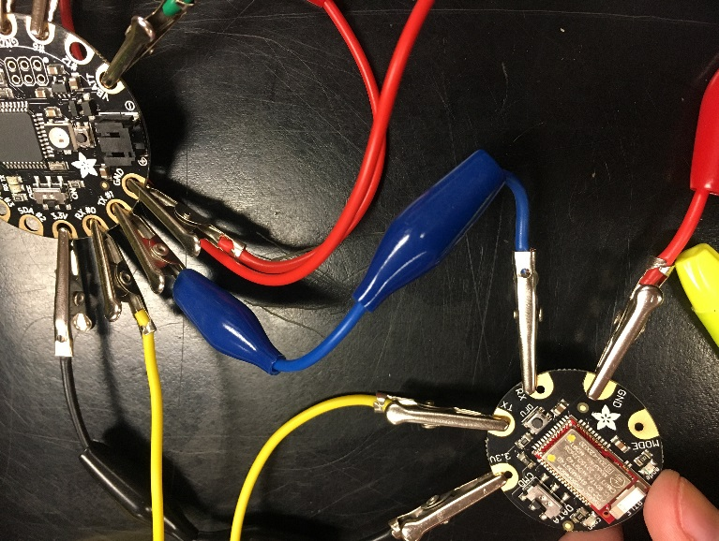
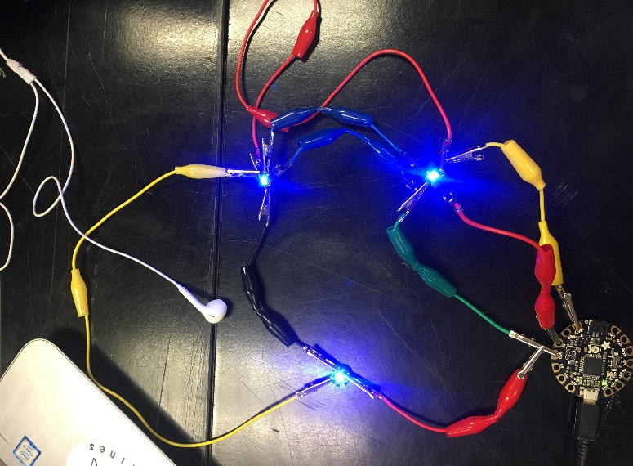
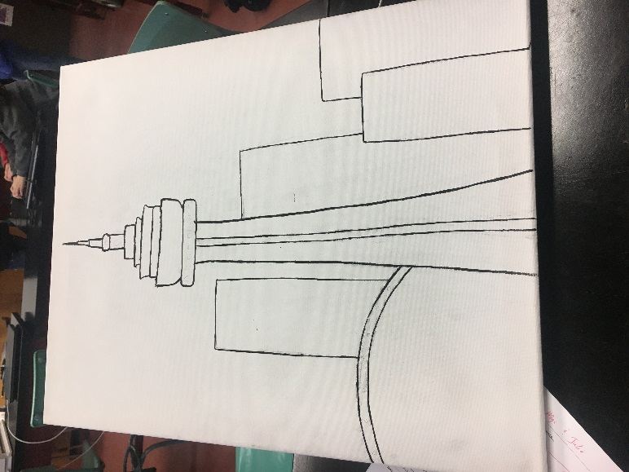
Jamie who is also from Brilliant Labs, said that if we succeed in actually being able to do the bluetooth, that it will be pretty cool to see, Jacob agreed. This has given us some more motivation to help with the project. We decided for our project that we are going to do a CN tower design on the canvas, which includes the Air Canada Center ( Blue Jays Stadium). This resulted in Mya using her art skills, so that she could draw and paint the design we are looking for. We also want the lights to have different patterns in behind the canvas since it’s bright enough, we were going to poke holes through the canvas, but it resulted in a mess because there was too much thread to clean up. If the bluetooth connection will not work for us we will have to stop using the bluetooth and start using the floraboard to have our light patterns, which will be easier for us, but we really want to succeed in using the bluetooth.

