Journal #2 Matthew ,Justin ,and Ryan
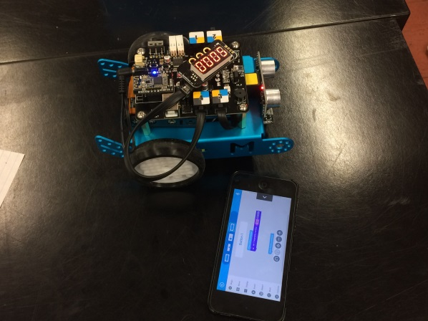
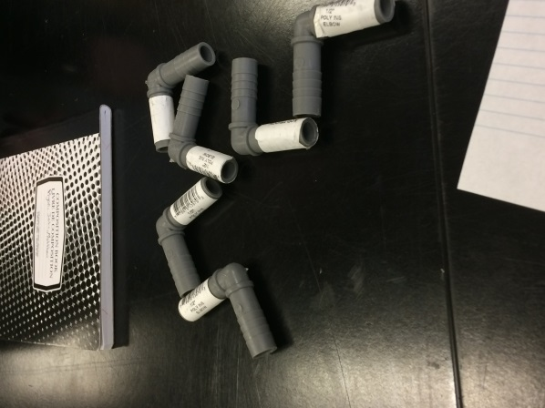
March 13th 2017 we started off with driving the mbots around making sure they worked and then we ran into a problem with one of the mbots as its wheel broke off. So then we had to fix the wheel with the extra parts that came with the mbot and followed the directions and failed the first time by making a minor mistake with the gears so we took it apart again and got the problem fix and now its good to go. Next we added a timer which we are in the process of trying to get it to count down time so we can have a timer for our soccer game. Then we figured out the dimensions of our nets and table. Also we have got our ball for the game.

