During the past month of our project we tried trouble shooting the connection with our neo pixels. We tested out a lot of soldering techniques that could help our project out a lot. For the last month we redid the entire project from scratch to make our soldering connection for persist. We figured out an easier method to soldering and not getting the connection mixed up with our other wires. We found out why our other project was not working because one of the yellow wires was burnt off the connection not allowing the connection to flow through smoothly. We found out that soldering a piece before putting the wiring on the strip is easier to getting the perfect solder. On May 12th we finally finished our project with the perfect connection. We took our project to stem fest and showed people our soldering and lights that we lit up.
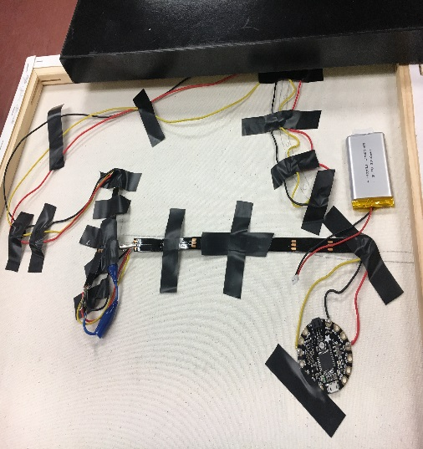
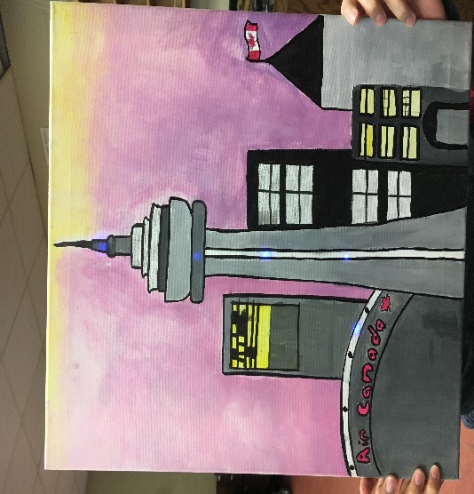
We think for our next project proposal we are going to do something with wearables and the circuit playground. We motion to allow us to touch a part in our shirt and let it change color or do something involved with the circuit playground. We have less than a month left so we are going to try to get as much done as we can before the end of the school year.
