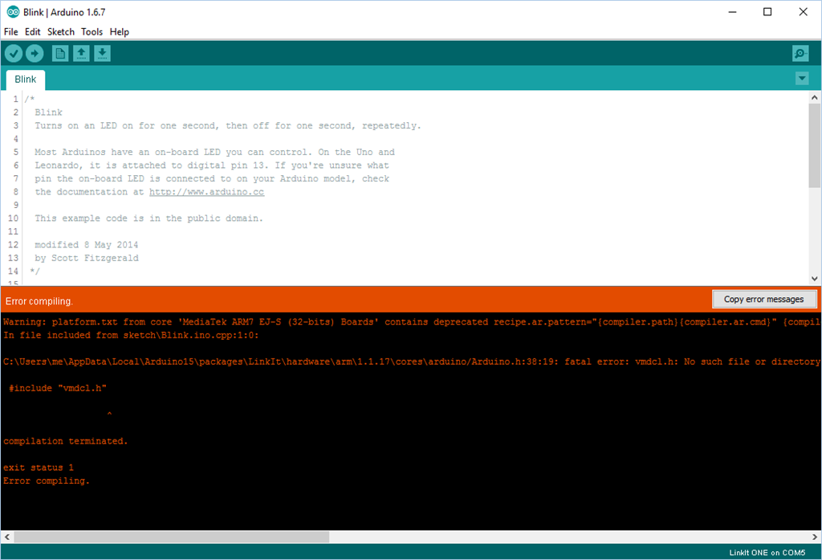
This is the forum post that helped me find where to put the sam.h file.

This is an example of what the error message said
Instead of #include “vmdcl.h”
Mine said #include “BluefruitRoutines.h”

