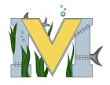
PROJECT #2 PROPOSAL
Name(s): Alex Tozer & Mitchel Hallihan
Team Name: Hot Stuff
Part A: Project Ideas & Objectives
- portable self-heating Coffee Cup
- 3d-Printed exterior layer
- Battery operated
- detachable base
- Vinyl Decals
- Miniature heating unit (Induction)
- Possible lighting
Part B: Electronic Resources (Make sure hyperlinks are active!)
Tinkercad- https://www.tinkercad.com/
Mini Heater design- https://www.youtube.com/watch?v=mBwFhHR0gdQ
Vinyl cutter help- https://vinylcuttingmachines.net/vinyl-cutting-101-everything-you-need-to-know-about-craft-cutters/
General 3d Printing/Vinyl/Lighting help- http://mvhs.nbed.nb.ca/other/mvhs-make?page=2
Induction Heater Unit- https://www.banggood.com/5V-12V-ZVS-Induction-Heating-Power-Supply-Module-With-Coil-p-1015637.html?rmmds=search&cur_warehouse=CN
Induction Heater Tutorials- https://www.youtube.com/watch?v=HvgM0awet9I
https://www.youtube.com/watch?v=_v5Hg2zfLjs
https://www.youtube.com/watch?v=UJ-1p6Bdz1E
Vinyl mug tutorial- https://www.youtube.com/watch?v=Irz7q45Dw2g
Soldering tutorial- https://www.youtube.com/watch?v=Qps9woUGkvI
Part C: Materials & Designs
- Copper wire (2-3 feet)
- 2 feet of electrical wire
- 9 volt or D batteries
- Single walled stainless steel mug (small)
- 3D Printer/filament
- Coffee
- Mini- Led lighting
- Switch
- Vinyl Cutter/Vinyl
- mini induction heater and coil

Design Ideas
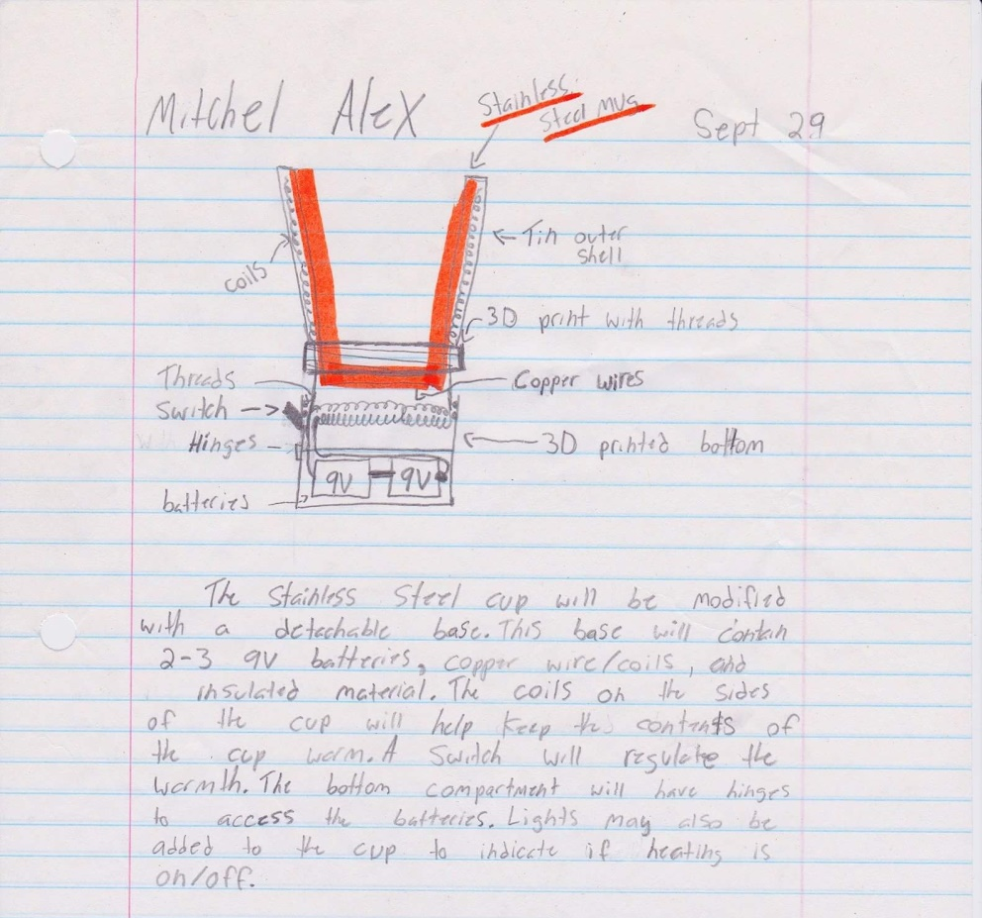
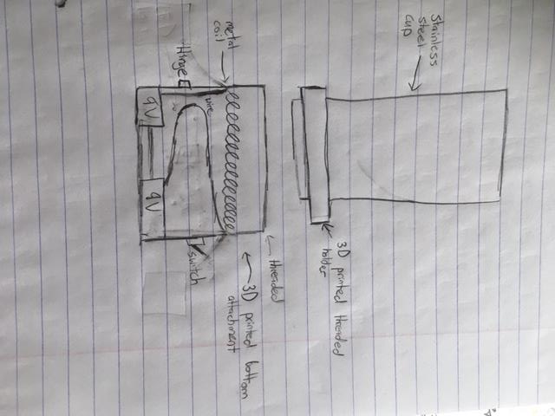Our two design ideas, the only difference being whether or not to put coils up the whole length of the cup or not. Induction unit will be added to the base of the mug for heating.

