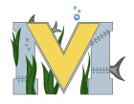
PROJECT #2 PROPOSAL
Name(s): Alexis Matchett and Robbie MacKay
Team Name: The Greenhouse Generals
Part A: Project Ideas & Objectives
Our idea is to use the grant we earned last year and use Raspberry Pi and the Sense Hat to record data in our greenhouse upstairs and a portable greenhouse that some students in Mr. Innis’ shop class and Mr. Hallihan’s Environmental Science class will build. They will build the portable greenhouse, and help us set up the hoses. We will help with the planting of the vegetables and flowers while we set up the technology parts of things.
For the plants and vegetables we grow, we will sell them and use that money towards other things for the Makerspace and Mr. Hallihan’s Environmental Science class. We were also thinking about giving some of the fresh vegetables to the food bank to give back to our community.
For technology, we will use the Raspberry Pi to act like a weather station with real time data, and use the Sense Hat to remotely record sensory data and upload it by Raspberry Pi’s Wi-Fi capabilities to a web page so the data can be accessed remotely. We also set up a micro drip system so the plants get watered with a hosing system on a timer instead of by us doing it at the same time every day, and place soil meters to check the different levels in the soil.
Our objectives:
-Learn how to use new technology
-Have something at our school that we haven’t had before
-Have something creating income so our Makerspace can purchase more resources and to help others complete their goals
-Give back to our community and the people in it
Part B: Electronic Resources (Make sure hyperlinks are active!)
https://www.youtube.com/watch?v=lnp6jo2XOU8
https://www.raspberrypi.org/
https://www.youtube.com/watch?v=Rj4MzjxjGck
https://i.pinimg.com/750x/21/00/07/2100074309ad25856a998ad267c8b64b.jpg
http://www.gardena.com/ie/water-management/micro-drip-irrigation-system/
https://projects.raspberrypi.org/en/projects/getting-started-with-the-sense-hat
https://www.arduino.cc/
Part C: Materials & Designs
-Gardena Micro-Drip-system
-Hoses
-Raspberry Pi 3
-Arduino and sensors
-12-volt digital solar charge controller
-Power Inverter
-3 way soil meter health wiser
-Statuary Fountain Pump
-Sense Hat
-Desktop, Mouse, Keyboard

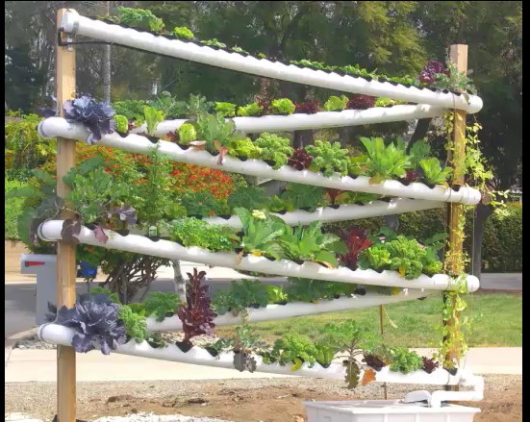
Hydroponic Garden Tower
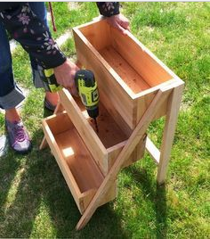
Plant Boxes

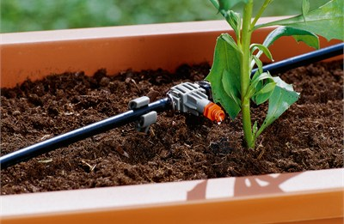
Gardena Micro Drip System

