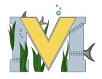
PROJECT #2 PROPOSAL
Names: James MacGregor
Team Name: Team MacGregor
Part A: Project Ideas & Objectives
- 3D print a T pipe so I can mount an acrylic air tight tube to the underwater robot for a camera to be placed in.
- Install a camera and lights to the front of the underwater robot and wire them to the control box.
- replace a broken propeller and secure the propeller guards so they don’t move as much.
- find a way to water proof the two light fixtures so nothing will short out.

My final objectives for the underwater robot is for it to function properly in water and for it to have a functioning camera and lights for different dives; such as the Miramichi river or local ponds.
Part B: Electronic Resources.
- Maker bot website(Program for our 3D printer)
https://www.makerbot.com/?utm_source=google&utm_medium=cpc&utm_campaign=CAN_EST_|_Brand_Core_-_D&utm_term=makerbot
- MATE underwater robotics website
https://www.marinetech.org/rov-competition-2/
- Tinkercad 3Ddesign software
https://www.tinkercad.com/
- how to install the camera
http://www.instructables.com/id/Installing-a-reverse-camera-and-monitor/
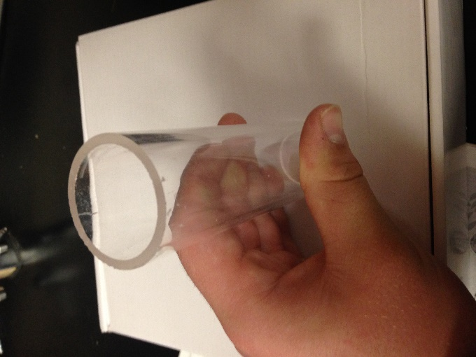
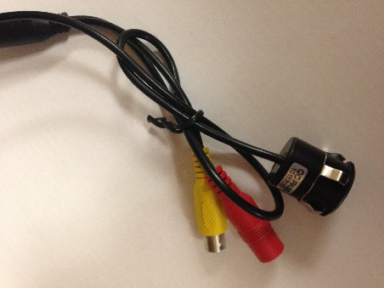
Part C: Materials & Designs
- silicone sealant
- PVC pipe
- Acrylic tube with an end cap
- Cameras with LED’s
- Electrical wire
- propeller
- 3D printer

