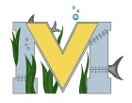
PROJECT #1 PROPOSAL
Name(s): Brianna Mullin
Team Name: Green Team
Part A: Project Ideas& Objectives
Ideas: Button Maker
Make pins
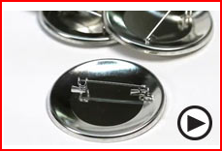
Key Chains
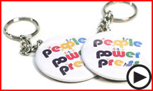
button bracelets
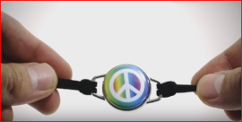
Try to get the pins to light up or blink or light up.
find a way to make the pins glow in the dark (maybe if I paint the design with glow in the dark paint it will glow in the dark)
invisible led ink that work with black light(If I can if a led ink pen I could draw or write a cool message or a cool drawing that will glow with a black light)
Create designs that will make people aware of the environment and will make them want to help the environment.
Part B: Electronic Resources (Make sure hyperlinks are active!)
http://thebuttonguy.net/videos.html
https://www.youtube.com/watch?v=PTWpVxlPnLI
https://www.youtube.com/watch?v=QRCiCs6BwyU&hl=en&fs=1&rel=0&autoplay=1
https://www.youtube.com/watch?v=-yuxvXEw9Go&hl=en&fs=1&rel=0&autoplay=1
https://www.youtube.com/watch?v=Ze5uc8-MWko
https://www.youtube.com/watch?v=JlUtQt0fVbM
Part C: Materials & Designs
Things I need for a regular pin:
- Shells
- Mylar
- pin back
- design
Things I need for a button bracelet:
- Shells
- Mylar
- Flat back
- magnetic bracelet base (try to 3d print the base then add a magnet afterwards)
- design
Things I need for a key chain:
- shell
- Mylar
- key chain slot back
- key chain
- design
Materials for blinking/light up pin
- Metal craft punch
- Flashing LED assembly

