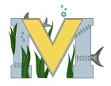
PROJECT #1 PROPOSAL
Name(s): jonah simon
Team Name: jonah simon
Part A: Project Ideas & Objectives
my project idea is to learn how to design, create and transfer my own hunting brand as a beginner design before i decide to create my own actual brand
Part B: Electronic Resources (Make sure hyperlinks are active!)
silhouettecameo

Part C: Materials & Designs
- T-Shirts
- heat transfer vinyl
- Vinyl heat press
- cameo

