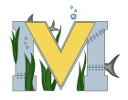
PROJECT #1 PROPOSAL
Name(s): Carmen Alvarez
Project: jewelry made with 3D printer

Part A: Brainstorming...
- describe your project idea(s)
MY PROYECT IDEA IS BASICALLY IS MAKE SOME MODELS OF JEWELRY IN TINKERCAD AND THEN PUT IN IN THE 3D PRINTER
- List your learning objectives
HOW TO DISEGNE JEWELRY IN THE 3D PRINTING PROGRAM

- State the goal(s) of your project

MY GOALS ARE FINISH THEM AND ALSO SOME FRIENDS ASKED ME ABOUT IT BECAUSE THEY WERE INTERESTED AND THEY WANT TO BUY SOME OF THEM

Part B: Electronic Resources…List active hyperlinks to any relevant online resources
https://www.thingiverse.com/
https://www.tinkercad.com/
Part C: Planning…
- Materials list [NOTE: if we do not have it, include link to purchase from Amazon.ca]
3D PRINTER AND MATERIAL
- Designs…Include any sketches/pictures and/or links to videos
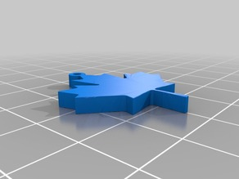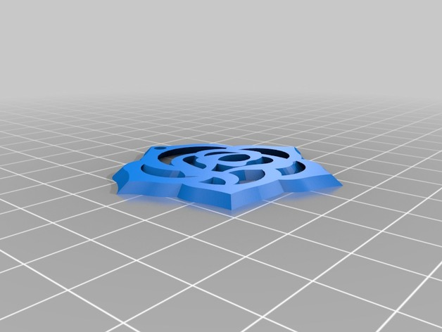 ETC

