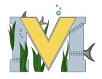
PROJECT #2 PROPOSAL
Name(s): Jackson Lirette
Project: Archery VR Project V2
Part A: Brainstorming...
- describe your project idea(s)
-Add sounds to the arrow
-allow player to teleport around using the vr controllers
-add a player model
-ADD TARGETS
-ADD STRUCTURES TO THE MAP
- List your learning objectives
-to learn how to code movement
-how to code a time limit
-how to add sound to an arrow

- State the goal(s) of your project
to add new elements to the game

Part B: Electronic Resources…List active hyperlinks to any relevant online resources

https://unity3d.com/learn/tutorials/topics/virtual-reality/movement-vr?playlist=22946
https://www.youtube.com/watch?v=4Z4VW2pSXNM
https://www.youtube.com/watch?v=6OT43pvUyfY

Part C: Planning…
- Materials list [NOTE: if we do not have it, include link to purchase from Amazon.ca]
VR Headset
Unity

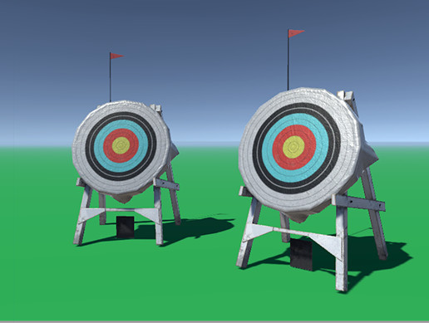
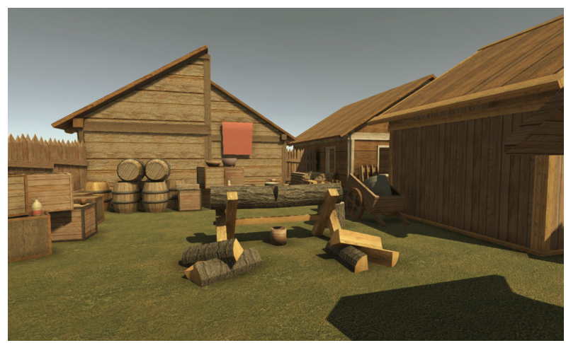
- Designs…Include any sketches/pictures and/or links to videos
