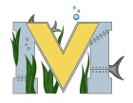
PROJECT #2 PROPOSAL
Name(s): Kevin martin-Savoie & David Wilson
Project: Miramichi Recreation: Blender
Part A: Brainstorming...
- describe your project idea(s)
Now that we have learned how to use terrain builder, we would like to focus on Blender to recreate the Centennial Bridge and possibly the school. Our main priority is to make a high quality steel through arch bridge. We want the bridge to be extremely high quality, so we’ll be focusing on it more than other objects we create, like I have stated before, the school. Other objects we could work on are the Beaverbrook statue, Beaverbrook House, Walmart, and the French Fort Cove Tower, covered bridge, Walking bridges, and other landmarks. We can probably incorporate 3d scanning as well once the snow goes away.
- List your learning objectives
Learn Basics of Blender.
Learn Advanced techniques required to make the bridge.
Learn how to add textures in Blender.
Learn how to add textures to objects in-game (Via paa’s and rvmats).
Learn how to Code Bridge into Arma 3.

- State the goal(s) of your project
Our main goal of this continuation of the project is to recreate the Centennial Bridge and some other landmarks, such as our school, French fort cove objects, and other objects if we have time. We also hope we can squeeze it into our previous project.

Part B: Electronic Resources…List active hyperlinks to any relevant online resources
https://www.youtube.com/watch?v=zOvawDOWqC4 (This is a youtube series)
https://www.youtube.com/watch?v=JYj6e-72RDs (Another youtube series, These series of videos will go through how to add textures and techniques to blender).
https://community.bistudio.com/wiki/Object_Builder (Program to put objects in arma 3)
https://www.youtube.com/watch?v=ZcsEyF5fH3o (This video is an hour long, but it will hopefully help with using Object Builder)
https://www.youtube.com/watch?v=GxGIgurkzW4 (This might be a better tutorial than previous)
https://steamcommunity.com/sharedfiles/filedetails/?id=405684985 (List of required programs)

Part C: Planning…
- Materials list [NOTE: if we do not have it, include link to purchase from Amazon.ca]
Arma 3 tools: Object Builder
Arma 3
Blender
Computer (Laptop/desktop)
Computer to run Arma 3 for testing purposes
Notepad++

Optional: (Blender can do all these things)
Sketchup (or equivalent)
3DS Max (https://www.autodesk.com/products/3ds-max/overview, Might be able to use Student Version, not sure, I think it is U.S. only)
http://store.steampowered.com/app/744570/Substance_Painter_2018/ (I might get it for myself, it is $170)

- Designs…Include any sketches/pictures and/or links to videos (next page)
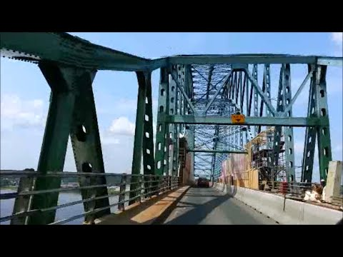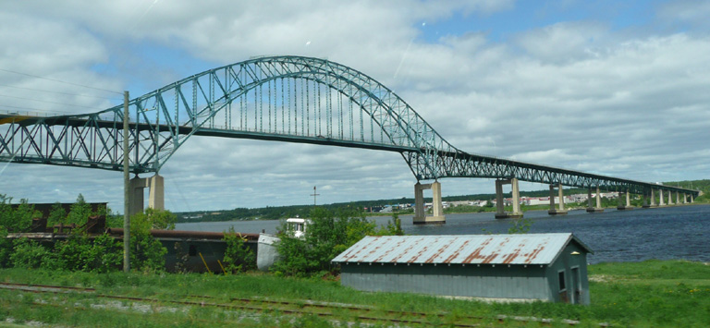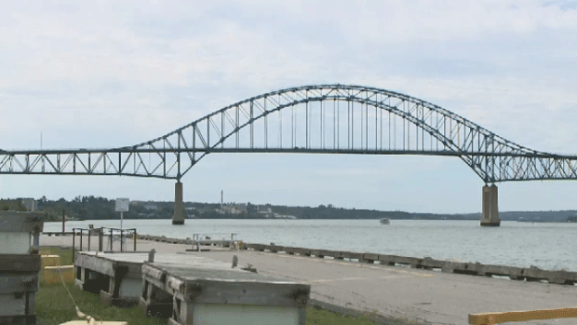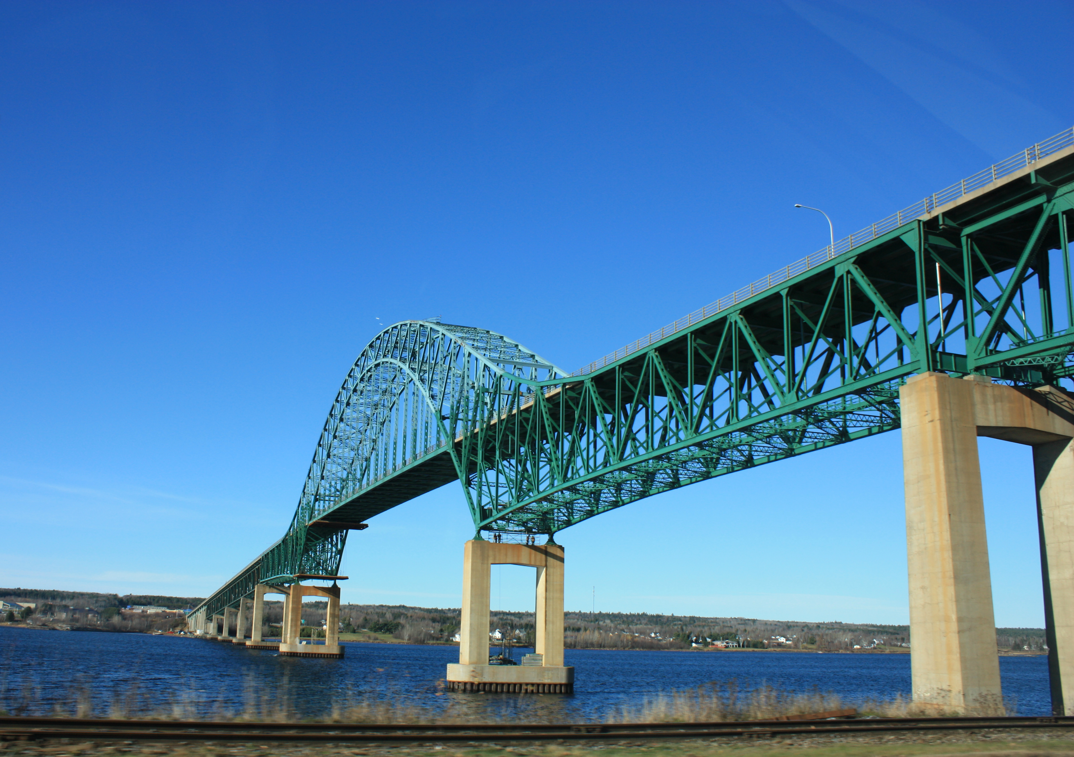

French Fort Cove:
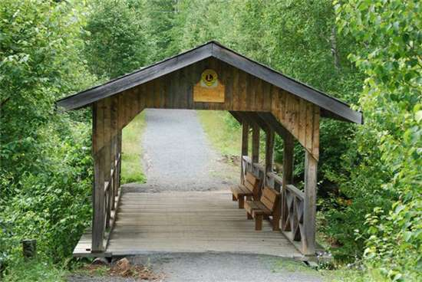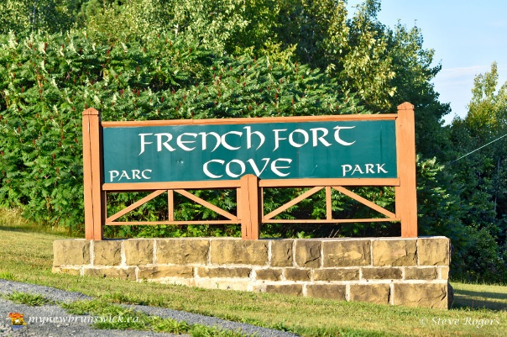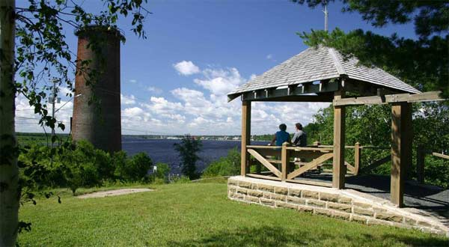
School: