PROJECT #1 PROPOSAL
Name(s): Grace Steeves
Project: Raspberry Pi Arcade Cabinet
Part A: Brainstorming...
- describe your project idea(s)
A wooden arcade cabinet with joysticks and buttons that can have 2 player games.
- List your learning objectives
assemble wooden cabinet
inserting and wiring buttons and joysticks to raspberry pi.
Set up Raspberry Pi and download ROMS
Configure controls
spray painting the cabinet and creating vinyl stickers for the buttons

- State the goal(s) of your project
To be able to play and load retro arcade games powered by the raspberry pi.

Part B: Electronic Resources…List active hyperlinks to any relevant online resources
http://www.instructables.com/id/2-Player-Bartop-Arcade-Machine-Powered-by-Pi/
https://www.iliketomakestuff.com/make-bar-top-arcade-cabinet/
https://www.iliketomakestuff.com/raspberry-pi-arcade-part-1/
http://www.instructables.com/id/how-to-make-a-vintage-arcade-marquee/
https://www.youtube.com/watch?time_continue=505&v=X6IX27FILus
https://www.youtube.com/watch?v=NUmrwvQ0reI
https://github.com/retropie/retropie-setup/wiki/Running-ROMs-from-a-USB-drive
https://lifehacker.com/the-always-up-to-date-guide-to-setting-up-your-raspberr-1781419054
https://lifehacker.com/how-to-turn-your-raspberry-pi-into-a-retro-game-console-498561192
https://www.makeuseof.com/tag/retro-gaming-on-the-raspberry-pi-everything-you-need-to-know-si/
https://aloshi.com/emulationstation
https://supernintendopi.wordpress.com/2013/01/23/an-a-to-z-beginners-guide-to-installing-retropie-on-a-raspberry-pi/
https://www.youtube.com/watch?v=hpLp929pM4c&feature=youtu.be

Part C: Planning…
- Materials list [NOTE: if we do not have it, include link to purchase from Amazon.ca]
Raspberry Pi
Clear Case For Pi
Heatsink For Pi
8 GB SD Card
4 Way Plug Power Bar
Fused switched mains inlet socket
monitor with built-in speakers
HDMI To DVI Cable
Joysticks + buttons + USB interface
12mm MDF board 1829 x 607
9mm MDF board 1829 x 607
6mm MDF board 1829 x 607
3m x 15mm coloured t-molding
750ml all-purpose white primer
400ml matte black spray paint
600mm brass piano hinge
Plexiglass 500 x 240mm
Flexible LED strip kit
USB keyboard and mouse
Screwdriver
Drill with ~28mm, ~12mm, and ~2mm bits
Clamps
Table saw
Jigsaw
Router
Sandpaper
Filler
Wood glue
Screws
Paint roller and small brush

- Designs…Include any sketches/pictures and/or links to videos
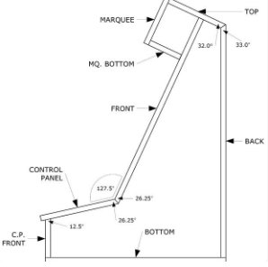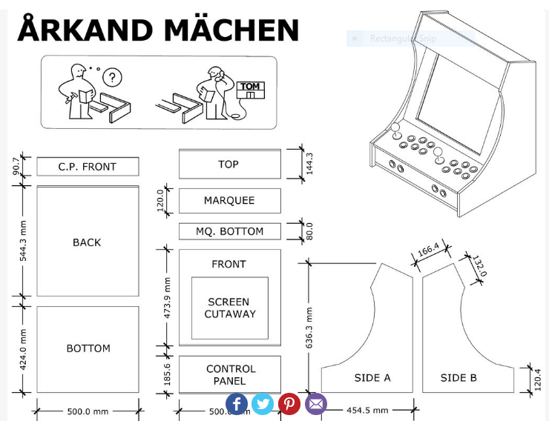

http://www.arcadecollecting.com/caga/marquees/

