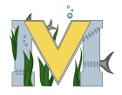
PROJECT #1 PROPOSAL
Name(s):
Project:
Part A: Brainstorming...
- describe your project idea(s)

- List your learning objectives

- State the goal(s) of your project

Part B: Electronic Resources…List active hyperlinks to any relevant online resources

Part C: Planning…
- Materials list [NOTE: if we do not have it, include link to purchase from Amazon.ca]

- Designs…Include any sketches/pictures and/or links to videos

