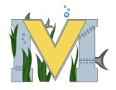
PROJECT #1 PROPOSAL
Name(s): Kevin Martin-Savoie & David Wilson
Project: Nordin Island
Part A: Brainstorming...
- describe your project idea(s)
We first started from the idea of making a map on arma 3, just a simple map, no satellite imagery, just a plain terrain. But then we thought about it more and looked at what arma 3 did with its “Altis” map (which is based from the real island of Lemnos). We’re planning on recreating Miramichi in the game. This will take a decent amount of time as we will need to recreate ALL terrain objects (such as tress, buildings, and roads). It will not be exactly miramichi, but we intend to make the map as faithful to miramichi as possible.
- List your learning objectives
We will need to learn how to create maps, objects, and script in arma 3’s coding language.
- State the goal(s) of your project
Our goal of our project is to re-create miramichi virtually on the game Arma 3. We will focus on getting the terrain in the game first, then we’ll focus on making models (such as the centennial bridge or the school)

Part B: Electronic Resources…List active hyperlinks to any relevant online resources
https://community.bistudio.com/wiki/Category:ArmA:_Terrain_Editing Bohemia Interactive resource (the game developers + Community tutorials)
https://community.bistudio.com/wiki/Terrain_Editing <-- Resources
http://www.bundysoft.com/L3DT/ Terrain generation
https://forums.bohemia.net/forums/topic/151620-resources-how-to-make-a-terrain/ Tutorials
https://forums.bohemia.net/forums/topic/91221-resourcelink-collection-how-to-make-a-map-beginning-from-the-idea-in-your-head/ A lot of tutorials & Resources
http://opentopo.sdsc.edu/raster?opentopoID=OTSRTM.082015.4326.1 Retrieve satellite images from real-life terrain
https://www.youtube.com/watch?v=EMjNQDfnP1E Tutorial video series

Part C: Planning…
- Materials list [NOTE: if we do not have it, include link to purchase from Amazon.ca]
1x Gaming-tier computer
1x laptop
- Designs…Include any sketches/pictures and/or links to videos
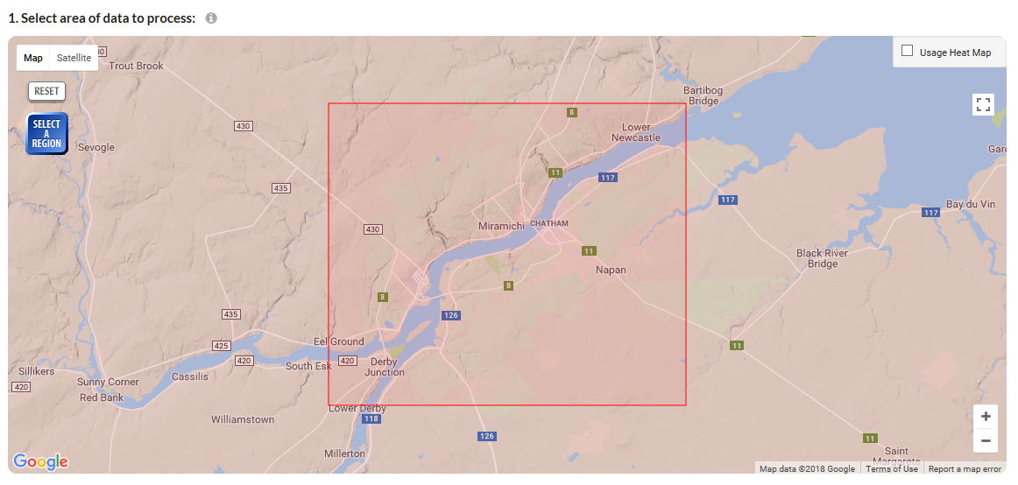
Area we’re planning on using ^
We will be turning it to an island, or the terrain will loop and look like garbage.
https://www.youtube.com/watch?v=8sRSdIiSDBo We aspire to create something similar to this.
Also here are some images of examples: https://imgur.com/a/5qIkO

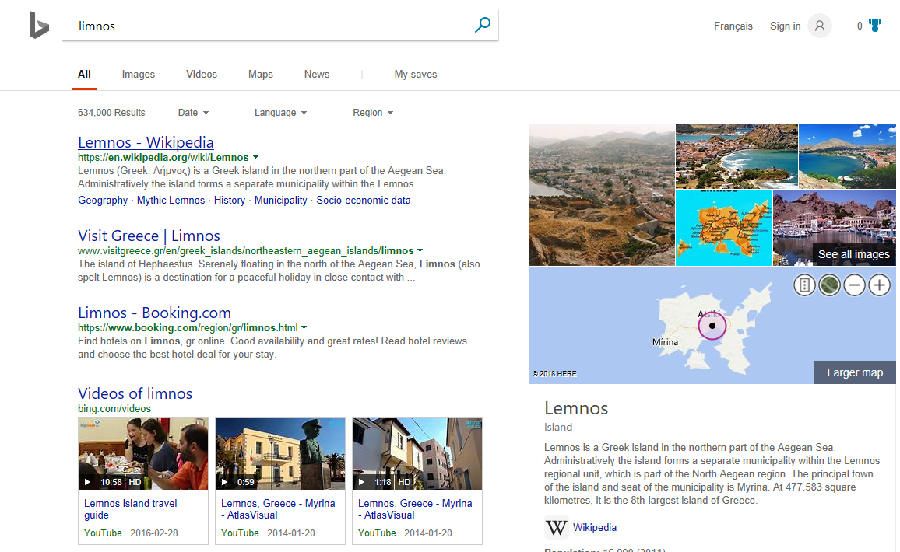
ARMA 3 Recreated Lemnos, we will do the same with Miramichi

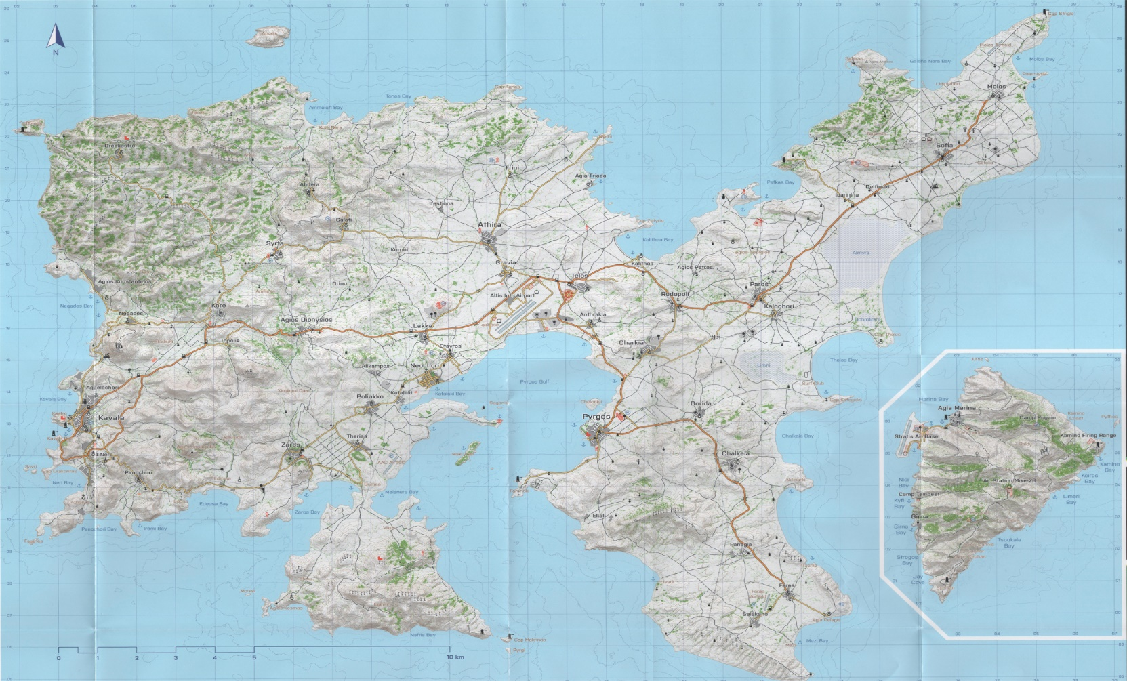
This is Altis, Lemnos recreated in arma 3.

