PROJECT #1 PROPOSAL
Name(s): Lasse Zeh, Vincent Herres
Project: Bluetooth RC Car
Part A: Brainstorming...
- describe your project idea(s)
For our project, we want to take a normal rc car, but transforming it into a bluetooth controlled rc car. We want to control it over an app from our phones. Added to that, we want to provide it with LED-lights, that light up in response to the direction the car drives.
- List your learning objectives
As we both did never build such a thing before, we are excited to learn all the basic electronic skills like coding, connecting the car to our phones with a bluetooth module, and especially programming an Arduino nano. For our design, we think of including the vinyl-cutter, and maybe the 3d printer.
- State the goal(s) of your project
The main goal will obviously be, being able to control the car with our phones. By controlling we mean, letting it drive a parkour or something like that. Also, we want to design it as best as possible. Depending on the project of others, we could organize a race between rc cars, if there are others.
Part B: Electronic Resources…List active hyperlinks to any relevant online resources
The instructable: http://www.instructables.com/id/RC-Car-Arduino-Project/
Part C: Planning…
- Materials list [NOTE: We highlighted the items we need purchase from Amazon.ca]
- any RC car toy chassis (Porsche 911 GT3):
https://www.amazon.ca/Porsche-Scale-Plastic-Model-Tamiya/dp/B000LFUB8K/ref=sr_1_6?ie=UTF8&qid=1519081760&sr=8-6&keywords=porsche+gt3+rc

- PCB:
https://www.amazon.ca/Gikfun-Solder-able-Breadboard-Arduino-GK1007C/dp/B06ZY75TWX/ref=sr_1_1?s=toys&ie=UTF8&qid=1519082232&sr=1-1&keywords=PCB
- one Arduino nano:
https://www.amazon.ca/Arduino-NANO-V3-0-Atmega328P-Development/dp/B01FV7NIUA/ref=sr_1_5?ie=UTF8&qid=1519257952&sr=8-5&keywords=arduino+nano
- HC-05 or HC-06 Bluetooth module:
https://www.amazon.ca/DSD-TECH-HC-05-Pass-through-Communication/dp/B01G9KSAF6/ref=sr_1_1?s=electronics&ie=UTF8&qid=1519082437&sr=1-1&keywords=DSD+TECH+HC-05+Bluetooth+Serial+Pass-through+Module+Wireless+Serial+Communication+with+Button+for+Arduino
- Light sensor BH1750:
https://www.amazon.ca/ILS-BH1750FVI-Intensity-Communication-Conversion/dp/B079124311/ref=sr_1_fkmr0_3?s=electronics&ie=UTF8&qid=1519082637&sr=1-3-fkmr0&keywords=HiLetgo+GY-30+BH1750FVI+Digital+Light+Intensity+Sensor+Module+For+AVR+Arduino
- Temperature and Humidity sensor:
https://www.amazon.ca/Temperature-Humidity-digital-interface-Arduino/dp/B075CNS7PS/ref=sr_1_fkmr0_1?s=electronics&ie=UTF8&qid=1519082829&sr=1-1-fkmr0&keywords=Qunqi+DHT11+Analog+Temperature+%26+Humidity+Sensor+for+Arduino+Raspberry+Pi
- L293D H-bridge motor driver (x 2):
https://www.amazon.ca/Adafruit-H-Bridge-Motor-Driver-Steppers/dp/B00NAY2URO/ref=sr_1_1?s=electronics&ie=UTF8&qid=1519083090&sr=1-1&keywords=Adafruit+Dual+H-Bridge+Motor+Driver+for+DC+or+Steppers+-+600mA+-+L293D+%5BADA807%5D
- RGB LEDs:
https://www.amazon.ca/Gikfun-Assorted-Arduino-100pcs-EK8437/dp/B01LZKPSS4/ref=sr_1_fkmr0_1?s=electronics&ie=UTF8&qid=1519083157&sr=1-1-fkmr0&keywords=Chanzon+100+pcs+5mm+RGB+LED+Diode+Lights+Tricolor+%28Multicolor+Red+Green+Blue+4+pin+Common+Anode+Clear+DC+20mA%2FColor%29+Super+Bright+Lighting+Bulb+Lamps+Electronics+Components+Light+Emitting+Diodes
- 5V buzzer:
https://www.amazon.ca/Elepartpro-Electromagnetic-9mmx5-5mm-MultiRotor-Appliances/dp/B01IJAIPH2/ref=sr_1_fkmr0_1?s=electronics&ie=UTF8&qid=1519083229&sr=1-1-fkmr0&keywords=RJXHOBBY+Loud+5V+active+RC+Alarm+Buzzer+Beeper+Tracker+12X9.5mm+for+FPV+Racing+Drone+10+PCS
- Header connectors:
https://www.amazon.ca/UEETEK-Breakaway-2-54mm-Connector-Arduino/dp/B075XJHV5P/ref=sr_1_fkmr1_3?s=electronics&ie=UTF8&qid=1519410135&sr=1-3-fkmr1&keywords=OCR+2.54mm+Breakaway+PCB+Board+Header+Connector+Assortment+Kit+for+Arduino+Shield+%2820pcs+40Pin+Male+and+Female%29

- Designs…Include any sketches/pictures and/or links to videos
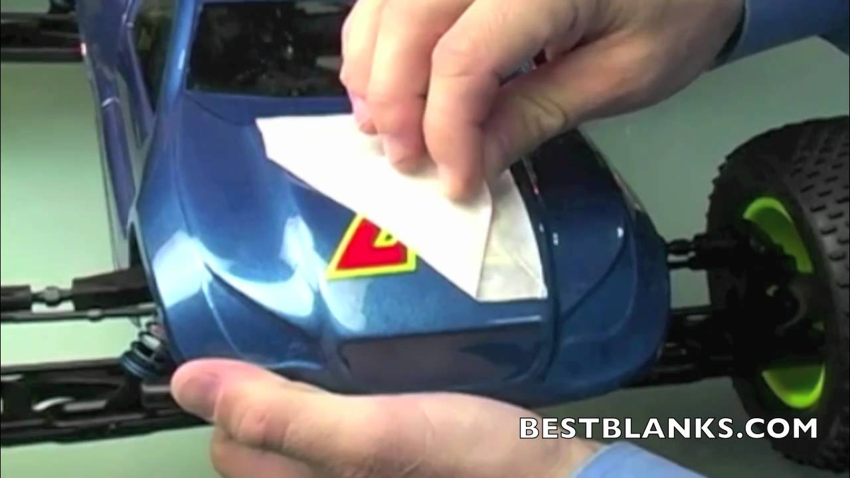
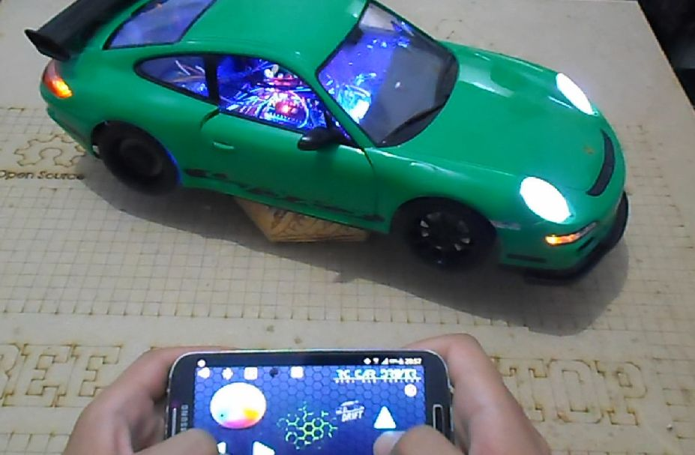
- https://youtu.be/Lx5w3OCO_Y0
As you can see we want to add LEDs and stickers made with the vinyl-cutter.

