What have we done thus far? Well, we have completely learned how to use Terrain Builder (Which took almost a month to learn every detail of it) and learned what each file extension does (Such as .asc’s which are for terrain height maps). We have also learned some of the basics for Blender (Which is for modelling). David can only use one hand so he must use a mouse with a number pad on it. The new mouse will be coming in sometime within the next few days and David will start to do more work and start the modelling of the centennial bridge.
Over the time of doing this entire project we have had MULTIPLE problems. One of the biggest problems right now is the fact that we have no way of getting terrain satellite images onto Arma 3 as of yet. Global Mapper Project costs $400, so we must find an alternative way on this. We were literally ready to have Miramichi projected onto Arma 3, until a paywall blocked us from doing so.
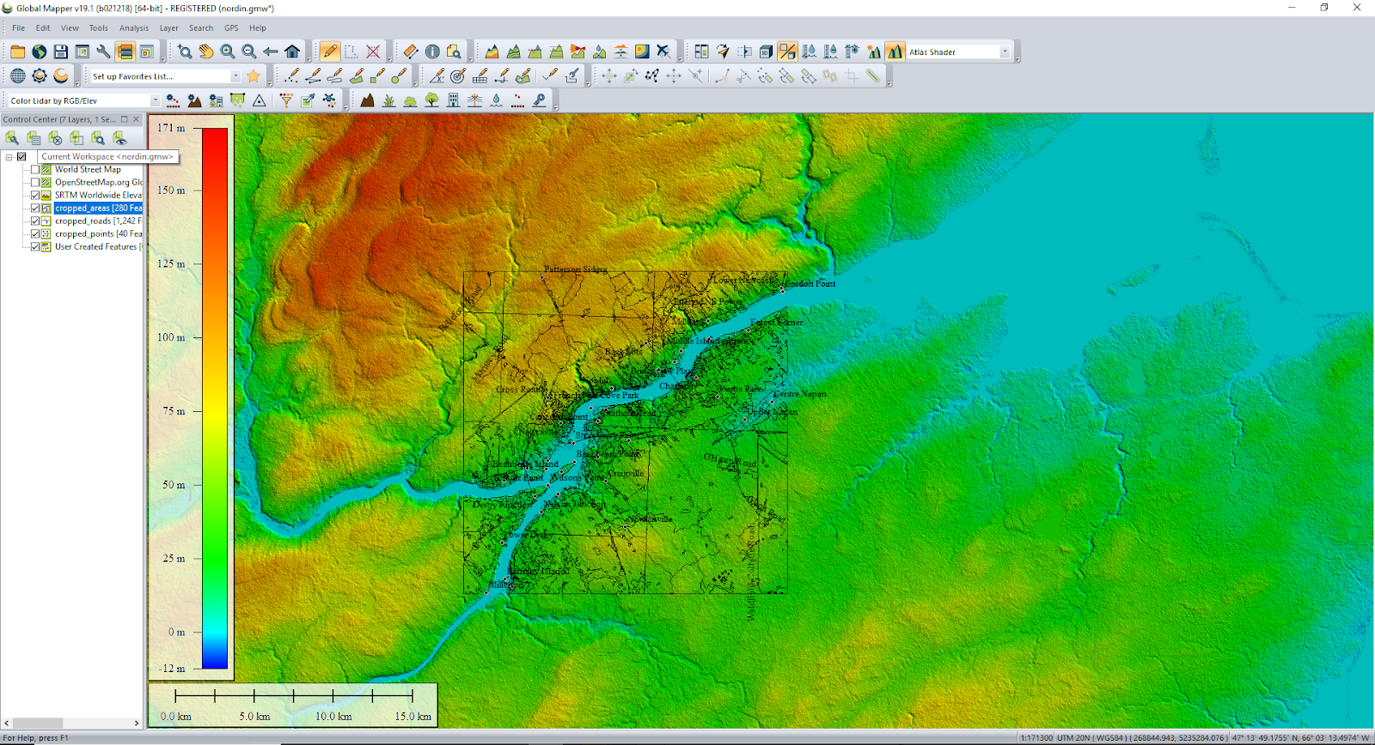
Other small problems is that we’re trying to find a way to get QGIS to work as an alternative. We have not found much about doing this, although we have spoken to people who have done it without Global Mapper (The person we spoke to said they forgot how to do it, so we know it’s possible). We know how to get the height map onto Terrain Builder for free, but the satellite and attribute maps, and roads are a different story as of right now.
Other minor problems were solved, such as getting Terrain Builder to work on the main computer, and unbinarizing the Arma 3 files from the main computer as well.
Tutorials for using QGIS and getting it into Arma 3 can be found here:
https://pmc.editing.wiki/doku.php?id=arma3:terrain:qgis-real-world-data
And here is the global mapper tutorial:
https://pmc.editing.wiki/doku.php?id=arma3:terrain:real-world-data-tutorial
The problem with the QGIS tutorial is that it is still Work in Progress, so it is incomplete. We can only get so far with it.
We’ve also experimented with using old Global Mapper files we were able to squeeze out of the trial.
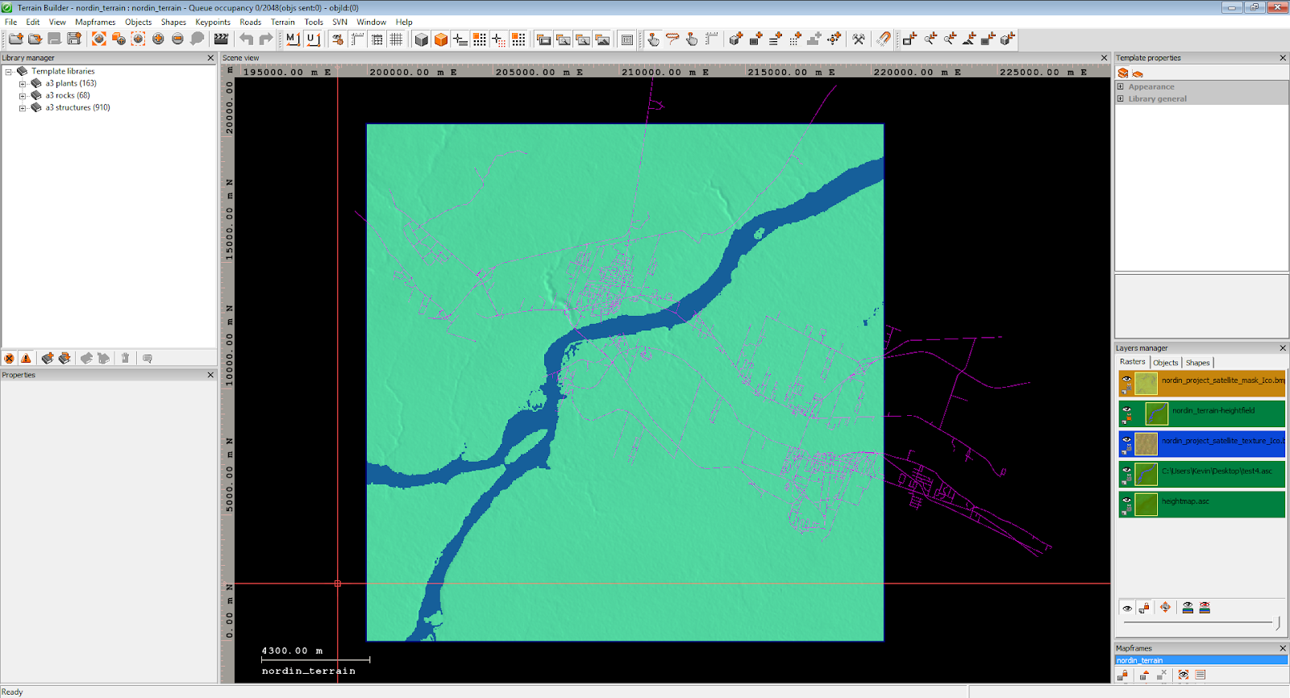
The purple lines are the roads, but it is a little disoriented as the height map is not the original size. The height maps size is 20.5x20.5 km, but it was changed to ease calculations. If we can change the size of the road shapefile, we can probably use it for our project, but then again, we should find an alternative way that doesn’t involve squeezing trial files out of programs.

