Kevin Martin-Savoie and David Wilson
So far, we have just been learning how to use Blender, it’s a complicated process because there is so much more you can do with it. It isn’t as simple as Autodesk 123D or any other CAD programs. It’s very unique, because there is buttons you can use to make something dissolve, or shatter, and pretty much everything. You imagine, it, you can make it in Blender. But so far we have just been trying to make the chimney near French Fort Cove for our starter object. We have mostly been playing around with the program and we have re-made the chimney a couple times. We were not happy with our results so we started over again. We’re also starting to work on the centennial bridge. We also got a test object into the game, so we’re definitely capable of putting any object into the game, although the process is a little long, and takes about an hour at most for one object.
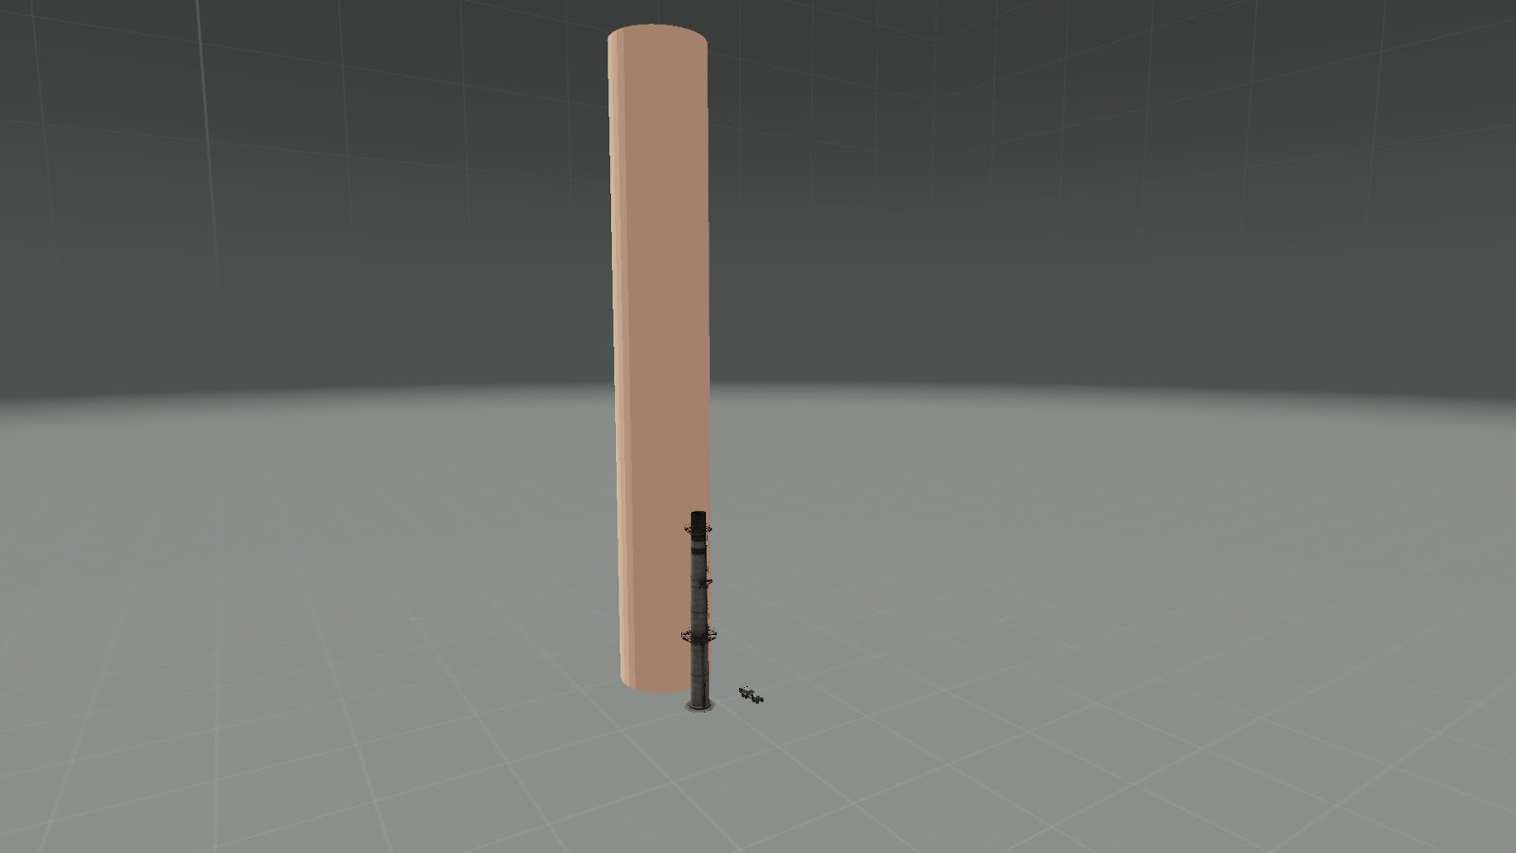
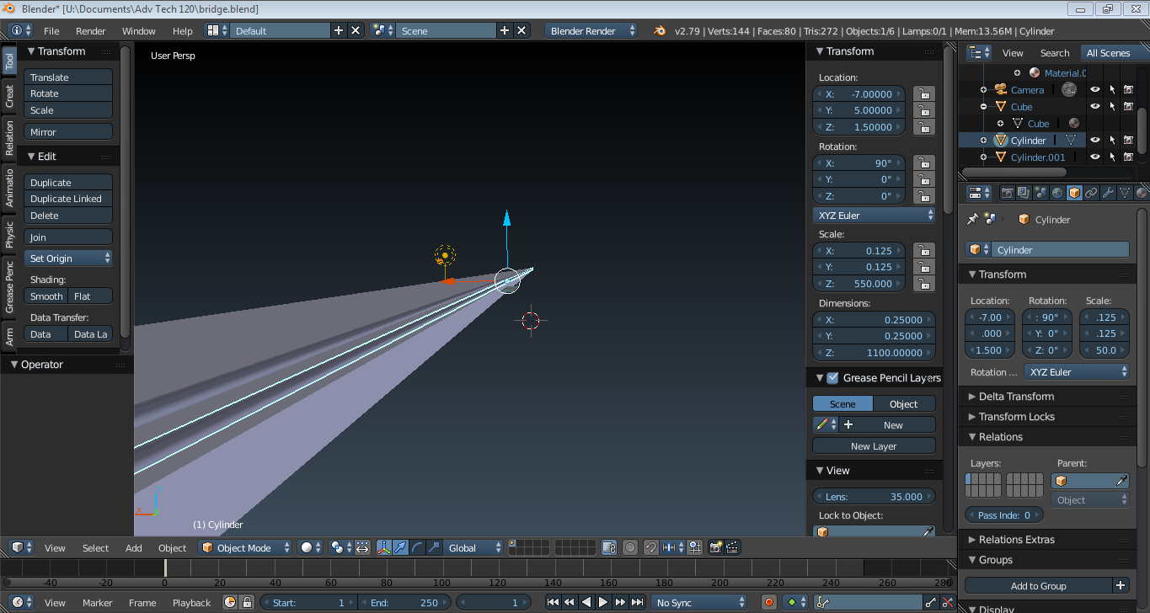
Centennial bridge, very W.I.P. as there needs to be more curves.
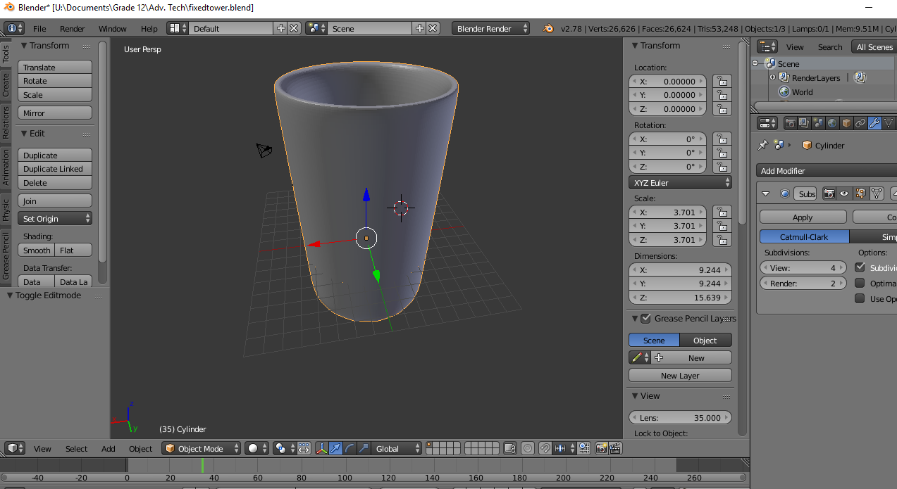
French Fort Cove Chimney, also very W.I.P.
Now for our current problems…
We need to get a texture painter program for texturing objects, but the best one we have found is Substance Painter 2018. It is $170 dollars, and that’s a big price tag. Kevin is working on getting it so we can make our objects look awesome, it also can be used to model objects further for more detail. Another thing is that when Kevin did put the object in-game he did a lot of things incorrectly, because we were able to simply walk through the object. But now that we know how to use Blender, we should be able to model objects more efficiently with competence with the program.

