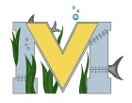
PROJECT #2 PROPOSAL
Name(s): Kaylee Russell & Erin Jimmo
Project: Heat Vinyl
Part A: Brainstorming...
- describe your project idea(s)
- T-shirts for the rainbow run, or Drag team shirts / others listed on the board.
- If we have time we will make ourselves t-shirts.

- List your learning objectives
- How to use the heat press machine.
- Designing skills.
- Being able to center and have the right measurements for shirts.

- State the goal(s) of your project
- To be able to make good enough shirts to be used for the events needing them.
- To gain knowledge on another part of the makerspace.

Part B: Electronic Resources…List active hyperlinks to any relevant online resources
- https://www.google.ca/search?safe=strict&biw=1280&bih=907&tbm=isch&sa=1&ei=8PPMWqjzI6PGjwSRppOwBg&q=future+lpn+shirt&oq=future+lpn+shirt&gs_l=psy-ab.3...747311.750685.0.751227.16.15.0.0.0.0.228.2092.2j8j3.13.0....0...1c.1.64.psy-ab..3.8.1472...0j0i67k1j0i24k1j0i30k1.0.jwwIpaLCp8M#imgrc=_

- https://www.silhouetteschoolblog.com/2014/04/silhouette-heat-transfer-vinyl-tips-for.html

Part C: Planning…

- Materials list [NOTE: if we do not have it, include link to purchase from Amazon.ca]
- t-shirts …………… https://www.amazon.ca/Gildan-Ladies-Sleeve-V-Neck-T-Shirt/dp/B00AWW9HZ0/ref=sr_1_2?ie=UTF8&qid=1523382371&sr=8-2&keywords=plain+t-shirts+women ……… We can get them from a local store though.

- Designs…Include any sketches/pictures and/or links to videos
- 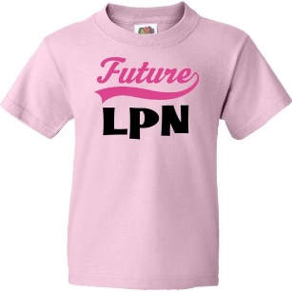
- 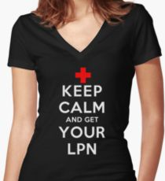 2 ideas for erin’s t-shirts.

