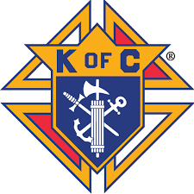 | Knights of Columbus  FR. B.M. BRODERICK COUNCIL, No. 1219  67 King Street  Miramichi, N.B. E1N 2N5  Telephone (506) 773-7225

Fr. B. M. Broderick/Ken Gouchie Memorial Scholarship

High School Graduates who are sons, daughters, grandsons or granddaughters of members (or deceased members) of Fr. B.M. Broderick Council 1219 (Chatham); and, who are planning to attend University, College or Community College may apply.

Name:………………………………………………………………………………………………….…

Address:………………………………………………………………………………………………….

…………………………………………………………………………………………………………...

Phone #:…………………………………………………………………………………………………

School:…………………………………………….. Principal:………………………………………

Name of Member sponsoring you & his relationship to you:

…………………………………………………………………………………………………………..

Post Secondary Institution you are planning to attend and course you plan to follow:

………………………………………………………………………………………………………….

Please enclose the following documentation:
- Proof of acceptance from Post-Secondary Institution;
- Transcript of final (or most recent) grades;
- Resume of school-related and other employment, activities and achievements;
- A letter of reference from a teacher or principal;
- A letter of reference from an employer OR extra-curricular activity supervisor from outside the school
community;
- Evidence of financial need;
List of other scholarships you have received (if any):……………………………………………..…

………………………………………………………………………………………………………..

Name of Parent(s) or Guardian(s):…………………………………………………..........................

Deadline for applications: The Friday before the Victoria Day weekend in May. Please mark
Attn: Scholarship Committee on envelope.

Revised 03/17

