Mr. Stewart’s Favorite Vehicle, #1
Like I mentioned, it is hard for me to pick just one, but I think this is it…
1970 Ford Mustang BOSS 429
I don’t know when I first fell in love with this vehicle but probably in early elementary school. Now I have been brought up a good FORD man, but I will be posting many different makes and models as my favorites. As a Ford guy I am a Mustang lover yes, but no other stands out in my opinion as the ultimate Mustang but this beast. I still have a couple model cars, from identical kits, that I put together when I was young of this very car.
Does anyone recognize this area in my class?
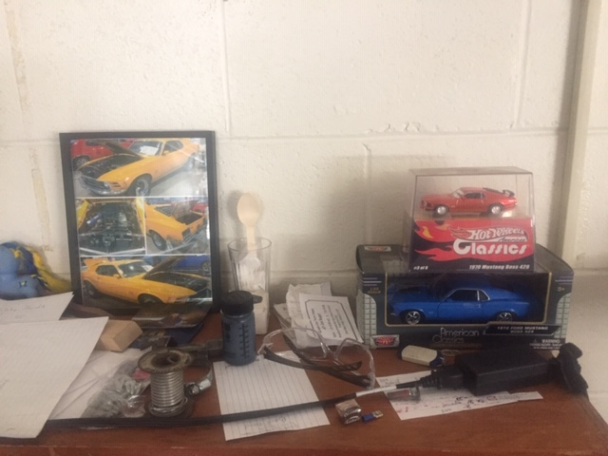
Well, if you’ve been in my class, and among the breathing you may have noticed this messy shelf that is four inches from where I set when I am at my desk. Yes, there are many things here. Among the notes, safety glasses, solder, glass and spoon, hose clamp, electrical connector, candy and a MV My Little Pony that my daughter made for me, you might notice a few 1970 BOSS 429 items. Come to think of it, I may post this picture on my page. We could play I spy for days. Anyway, these are a few pieces that I received from students that knew what my favorite was.
For many years in Racing, for a company to run a new engine or setup, it had to be sold to customers in a regular production car of at least five hundred copies. Many super powerful and super rare muscle cars were born this way in the 60s and early 70s so companies could please the racing rules and not get disqualified for cheating. The stock 1969 and 1970 ford mustangs went under heavy modifications to be able to house this monster engine and to support its much-underrated quantities of horsepower. This “semi-hemi” big block Ford had “rated” hp of 375hp and 450 pound-feet of torque, real-life modern-day numbers were closer to 500 and 600. Cost for a new one in 1970 was less than $5000. Now? A quick google search told me one sold at auction for $245000 and there is a 1969 model for sale with the asking price of $429 900. Wow.

I didn’t think I would ever have the opportunity see my childhood dream car in person. Lucky for me, a gentleman in Moncton NB who is a car collector acquired a 1970 BOSS 429 and two other rare BOSS Mustangs. I have never met the man, but I thank him for not hiding it away somewhere and for taking it to many auto-shows during the summer. The Mustang framed on my shelf in the above picture is that very car, and I’ll put in a few more pics in a minute.
I had taken my MV DRAG TEAM to the Moncton car show a few years back as I usually do, and I got a little surprise. Winding through the rows of cars I stumbled across my Wayne Gretzky, Mike Tyson or my Jonny Cash. Any guesses? Oh, you’re good, a 1970 BOSS 429. Everyone thought it was a nice old car in great original condition, but not me. Yes, it was that, but also so much more. Just Awesome! They didn’t know what it was like for me, to see the thing that I had looked at, thought about and read about growing up. In my opinion it is the best looking and one of the most brutally powerful mustangs of all time. I know, you don’t have to tell me that in recent years Ford has produced many more powerful, more comfortable and more efficient Mustangs, but I am a stickler for old school and crazy.
Well that’s #1. Now that I have thought about it, I think it is my favorite car of all, but I’ll give you some more examples in the days ahead. Take a minute and look up this vehicle and learn more. This is my first example of what one of these projects can look like also. Please put one together and have fun doing it. Thanks for the interest, guesses on the “ugly” vehicle and sending in the projects. Feel free to do more than one. Now I’ll leave you with some more pictures.
The next three pictures were taken by me in Moncton.
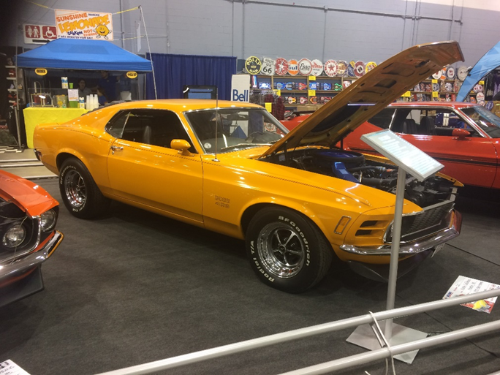
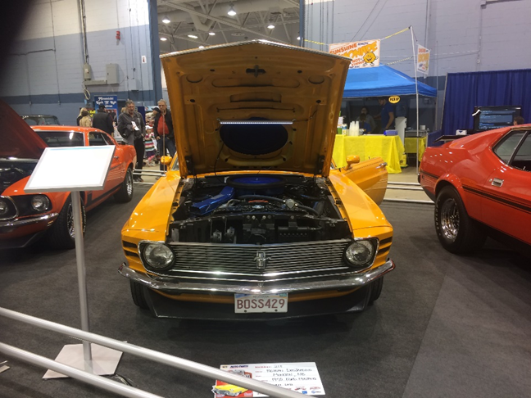

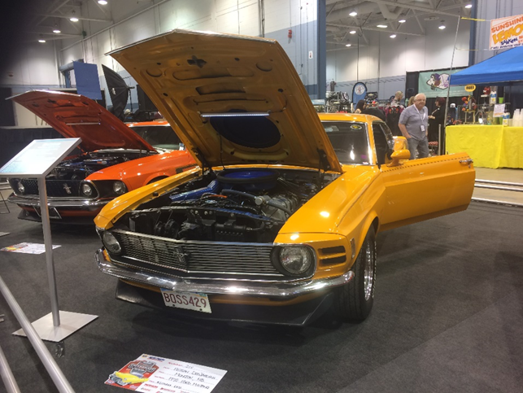

This next one is a picture of the awesome power plant under the hood. With its “close to Hemi” cylinder heads and ginormous size overall, it was pleasing to the eye and gave very large wow effect.
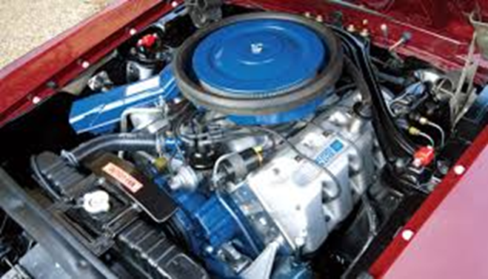
This is the cover of BONE STOCK magazine from spring 2018 that I just had to keep. Look at what is right in the middle! This issue has the story of the before mentioned gentleman’s trio of BOSS Mustangs.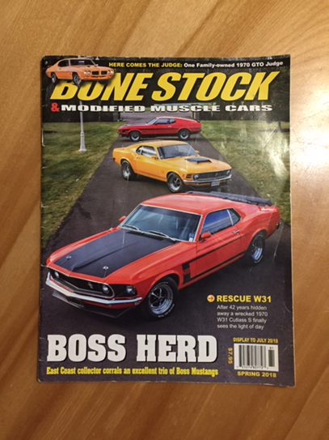
And what do you think got the centerfold all by itself? There it is, the ‘70 BOSS 429.
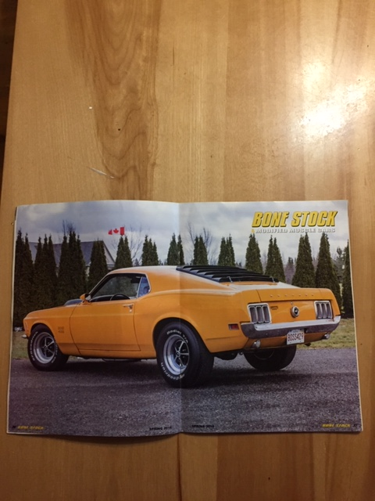

Article: Evans, Roger, Terry Denomme. “BOSS HERD” Bone Stock Spring 2018: 24-35. Print

