Hello Everyone,
It’s time for my #2 car pick.
Well now, let me see. I guess I’ll stick to the Ford products for a bit, at least until everyone gets tired of my brain washing. Excited?
Vehicle #2, 1965 427 Shelby Cobra
I’ll try to keep this one short. I’ve waisted enough of my life learning about and studying vehicles, now it’s your turn to look some up. So again, google it with all this time on your hands and any other vehicle or automotive question you might have.
This vehicle was again a little crazy. Ever hear of Carrol Shelby, Shelby Mustangs, Shelby Cobras, Mr. Stewarts car #3, or watch the late movie Ford vs Ferrari? If you haven’t, you need to leave the world of Forza, Grand Turismo and Fortnite and learn about something out here in the real world, especially if you have an interest in vehicles. Mr. Shelby was a racecar driver, builder and vehicle modifier responsible for all these things and so much more. After being told he could no longer race because of a heart condition, he spent his life making cars go fast and making them just plain awesome. Being a true Ford guy, he adapted Ford small block V8s into British made AC sports cars with modifications to chassis and suspensions also. These things now were a true performer and Shelby, calling them Cobras, had a lot of fun playing with and taunting vehicles like the Corvette and other major sports cars of the day. My favorite though is the 427 Cobra. This time Shelby really went nuts. He took the already popular and supremely powerful Ford 427 race engine and shoehorned it into one of these tiny little sports cars. The result? Epic. Though that is my opinion, it is shared by many. The reality is this thing could bury just about everything on the planet at that time and still is a true performer even by today’s standards. Another reality was though, most people did not even have the skills to deem it drivable. You had to know what you were doing, or you would surly crash, as was the fate of more than a few of these vehicles.
I’ll leave you with some pictures to enlighten your interest or show you what this vehicle looks like. These are picks of toys or models that are in my home. I can’t afford cars that are now worth in the five hundred-thousand-dollar range for an original, so these will have to do. Enjoy!

This is a 427 Cobra windup car on my boys’ shelf.

These are pictures of a detailed model that I own. Your all lucky because this is the first time it has been out of the box. Even the exhaust is heat-discolored like the real thing.
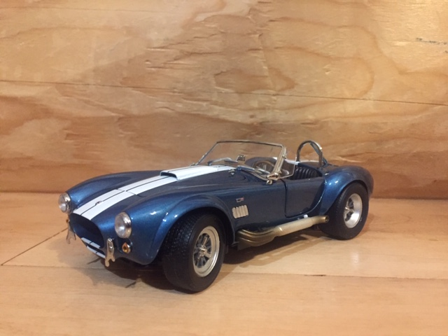
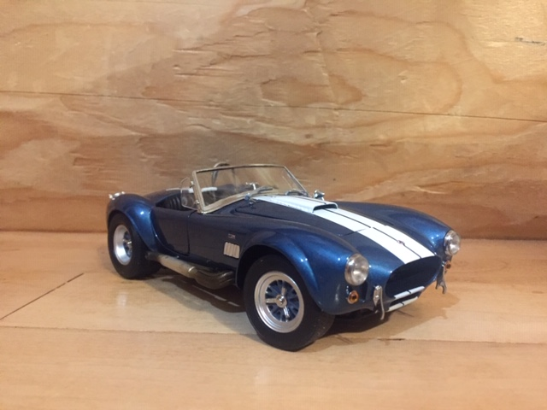
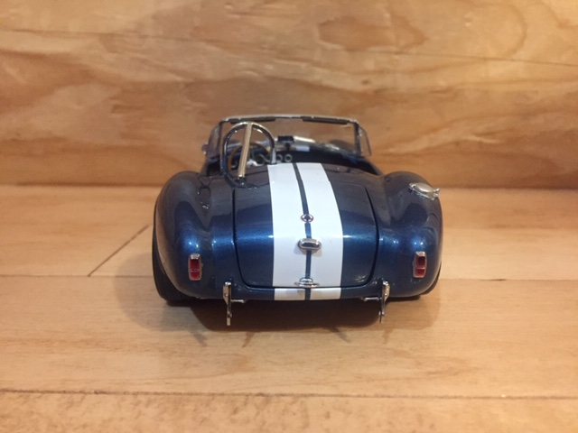

Small, beautiful and effective.
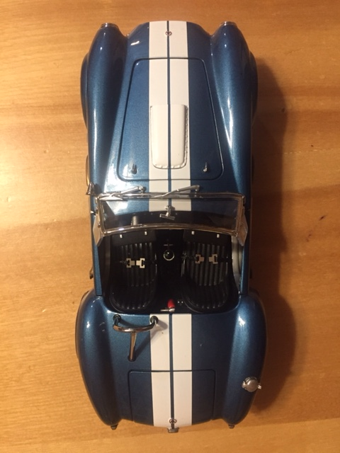
Ah, the mighty 427!
