Hey Folks,
Now I said that number 3 would most likely be another Ford, and I mentioned it in favorite vehicle number 2, but it’s time for the moment you’ve all been waiting for, Favorite Vehicle #3, The GT-40!
Like I said before, I have been brought up on the superior auto maker Ford, so I’ve known the whole “Ford vs Ferrari” story for as long as I can remember. The recent movie of this title tells the tale of how Ferrari backed out of a company sale deal with Henry Ford II, and this evoked revenge on Ferrari from Mr. Ford. Ford being the worldwide auto superpower that it was and is, spared no expense in completing the task. As the story goes, Ford, though it was a lengthy process, built a vehicle that beat Ferrari at LeMans, the world’s greatest race of endurance, a race that Ferrari had dominated for many years. This vehicle was the GT-40.
The completed GT-40 in my favorite form, the 1966 Mk.II, with a similar 427 cubic inch engine to the 427 Cobra, was supreme at LeMans. It was a great day for Ford when the GT did not only beat Ferrari, or win, but came in first, second and third places, thus sending the message that you don’t mess with Ford. The story is a great one in automotive history, especially if you’re a Ford follower at heart.
Again, I’ll keep it short. Watch the movie if you get a chance because it is decent overall. If you’re interested in learning more, want to know about the hard work involved or want the less “Hollywood” version of the story, send me an email. I have many books on the topic of GT-40 and would be happy to lend them.
Once again, I’ll leave you with some non-copyright issue pictures of some of my favorite play toys. No, they are not the real thing, but will give you an example of its power, shape and statement.

What a machine!
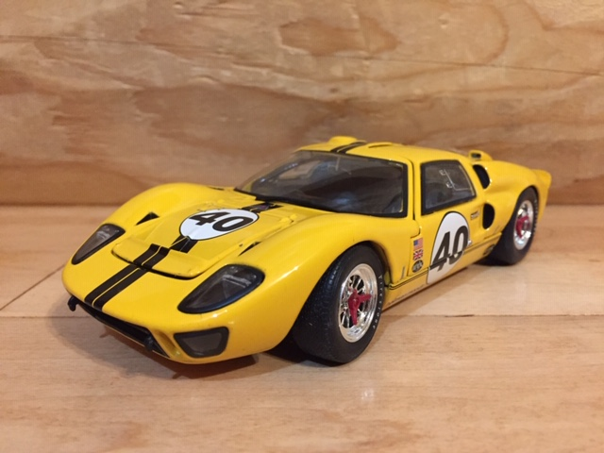
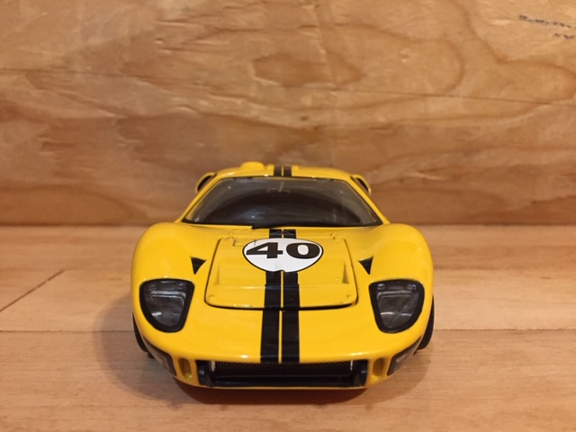

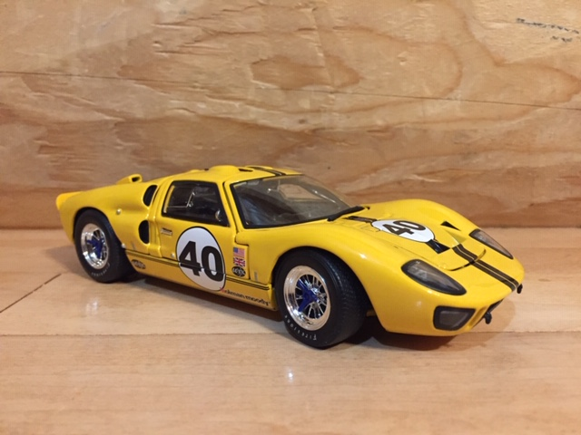

The View that every other car at LeMans Seen, the rest is history!
